**COLLEGE OF DEFENCE MANAGEMENT**

**DATATHON – 2023**

**GLOBAL TERRORISM DATA**

**DATA ANALYTICS BY USING ELK STACK**

1. **Introduction.**
2. The ELK stands for: Elasticsearch, Logstash, and Kibana. Often referred to as Elasticsearch.
3. The ELK stack gives you the ability to aggregate logs from all your systems and applications, analyze these logs, and create visualizations for application and infrastructure monitoring, faster troubleshooting, security analytics, and more.

(c) Elasticsearch is a distributed search and analytics engine built on Apache Lucene. Support for various languages, high performance, and schema-free JSON documents makes Elasticsearch an ideal choice for various log analytics and search use cases.

(d) Logstash is an open-source data ingestion tool that allows you to collect data from various sources, transform it, and send it to your desired destination.

(e) Logstash is a lightweight, open-source, server-side data processing pipeline that allows you to collect data from various sources, transform it on the fly, and send it to your desired destination.

(f) In this project we have used it as a data pipeline for Elasticsearch, an open-source analytics and search engine.

(g) Kibana is a data visualization and exploration tool used for log and time-series analytics, application monitoring, and operational intelligence use cases. It offers powerful and easy-to-use features such as histograms, line graphs, pie charts, heat maps, and built-in geospatial support. Also, it provides tight integration with Elasticsearch, a popular analytics and search engine, which makes Kibana the default choice for visualizing data stored in Elasticsearch.

(h) How we have utilised the ELK stack in datathon 2023?

1. Logstash is utilised for ingesting, transforming, and sending the data to the right destination.
2. Elasticsearch has indexed, analyzed, and searched the ingested data.
3. Kibana has visualized the results of the analysis.
4. Further it is utilised to solve the complexities in the dataset, including log analytics, document search, security information and event management (SIEM), and observability.
5. It is used in this project for search and analytics engine, data ingestion, and visualization.
6. **Methodology.**
7. The initial script of ElasticSearch is loaded by running elasticsearch.bat

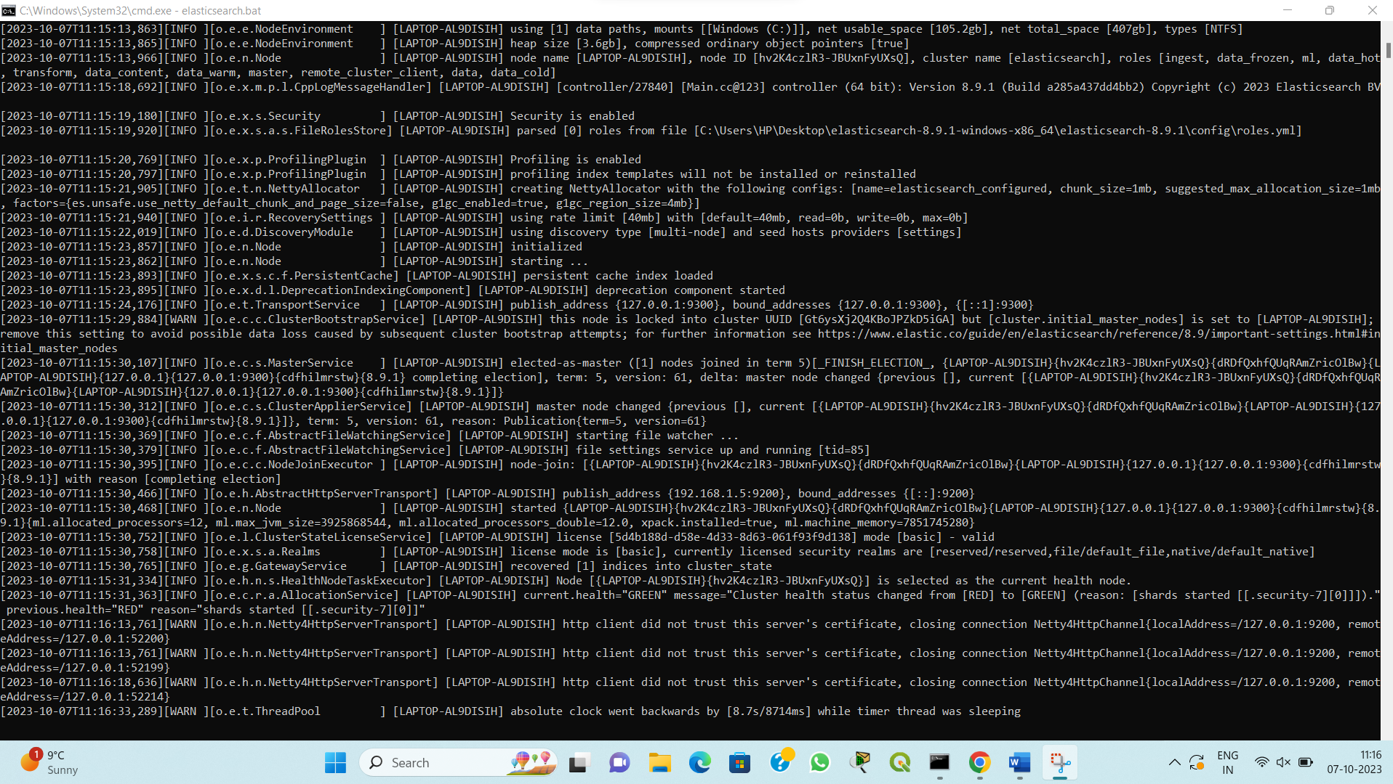

1. The security and authentication features are additionally added in the elasticsearch.yml file

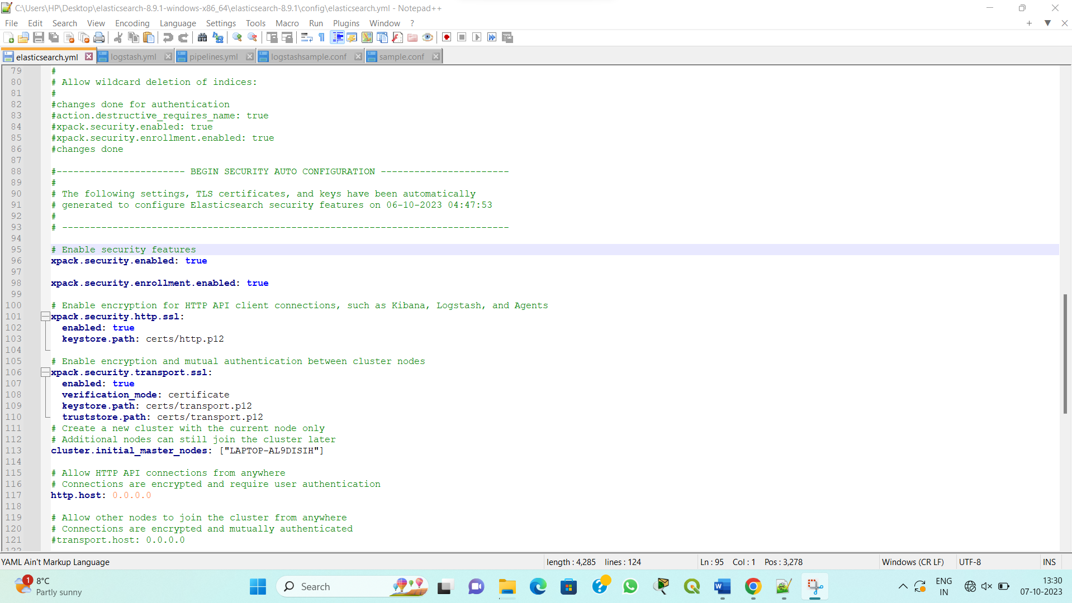

1. ElasticSearch started running at localhost at 127.0.0.1:9200

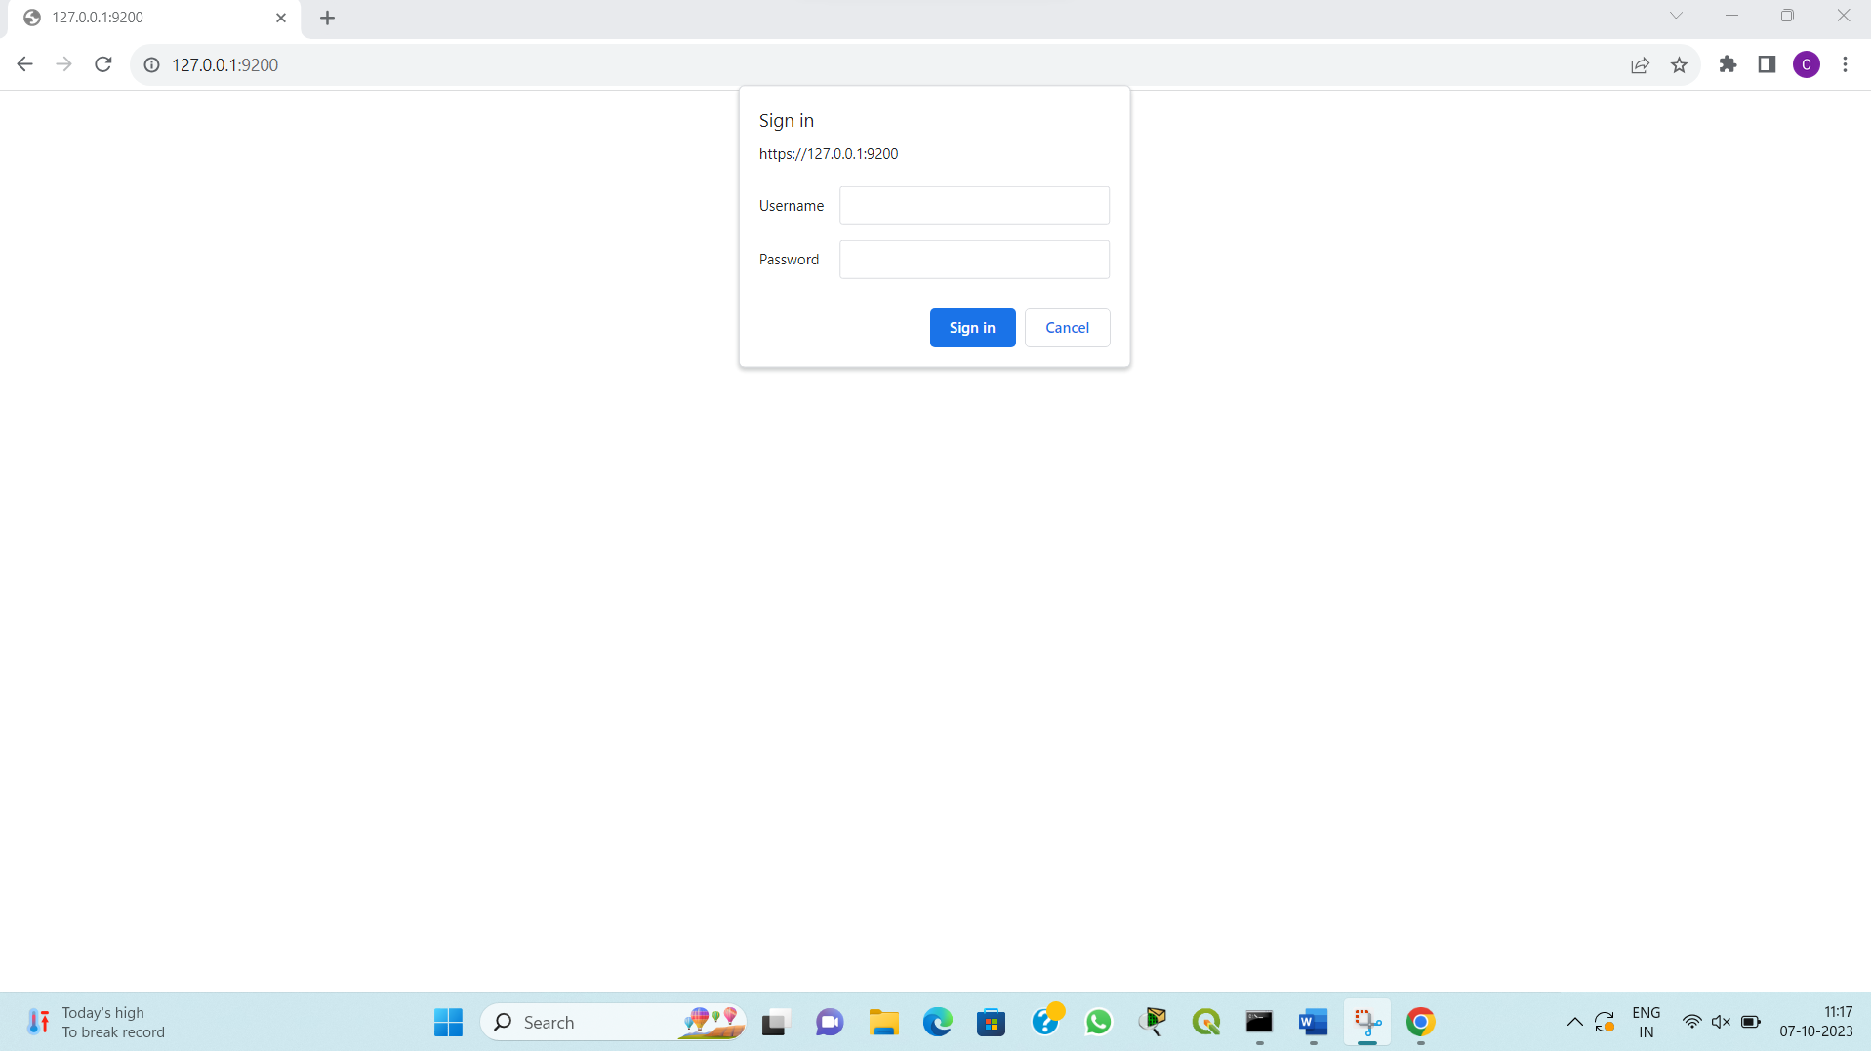

1. Username and password has been set in yml file as ‘elastic’ and ‘elastic’ respectively.

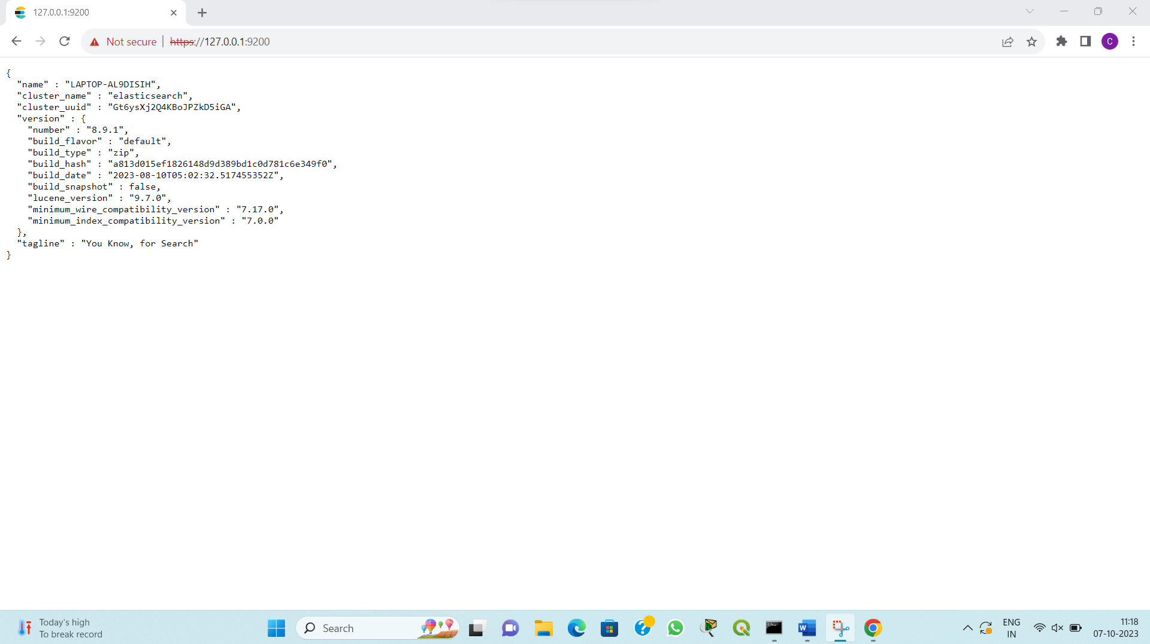

1. The logstash script is edited to integrate the dataset from elastic to kibana dashboard.

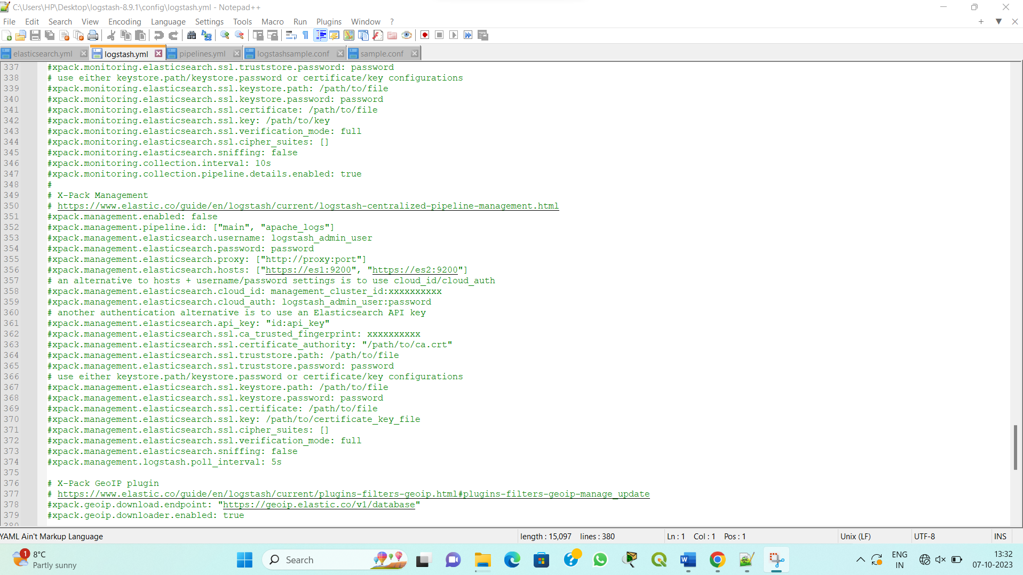

1. The pipelines.yml script is edited to make a pipeline in between the three components of the stack.

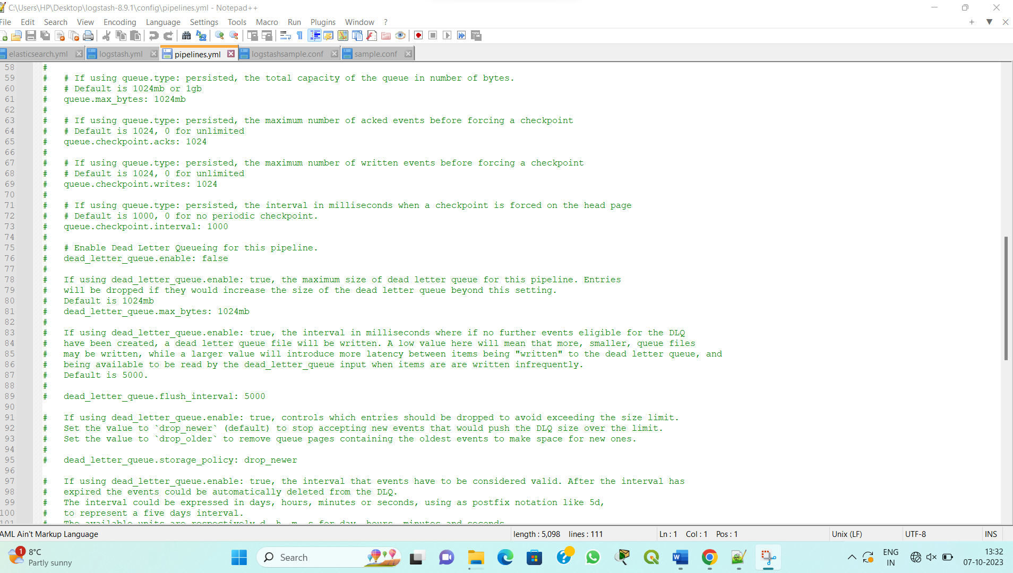

1. A sample configuration file is build to integrate the data.

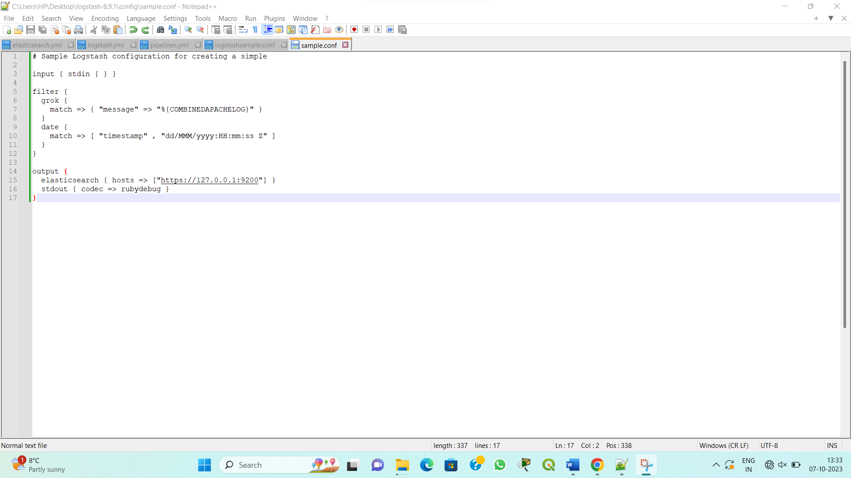

1. The kibana script is edited to run on port 5601 along with fetching the data from the logstash.

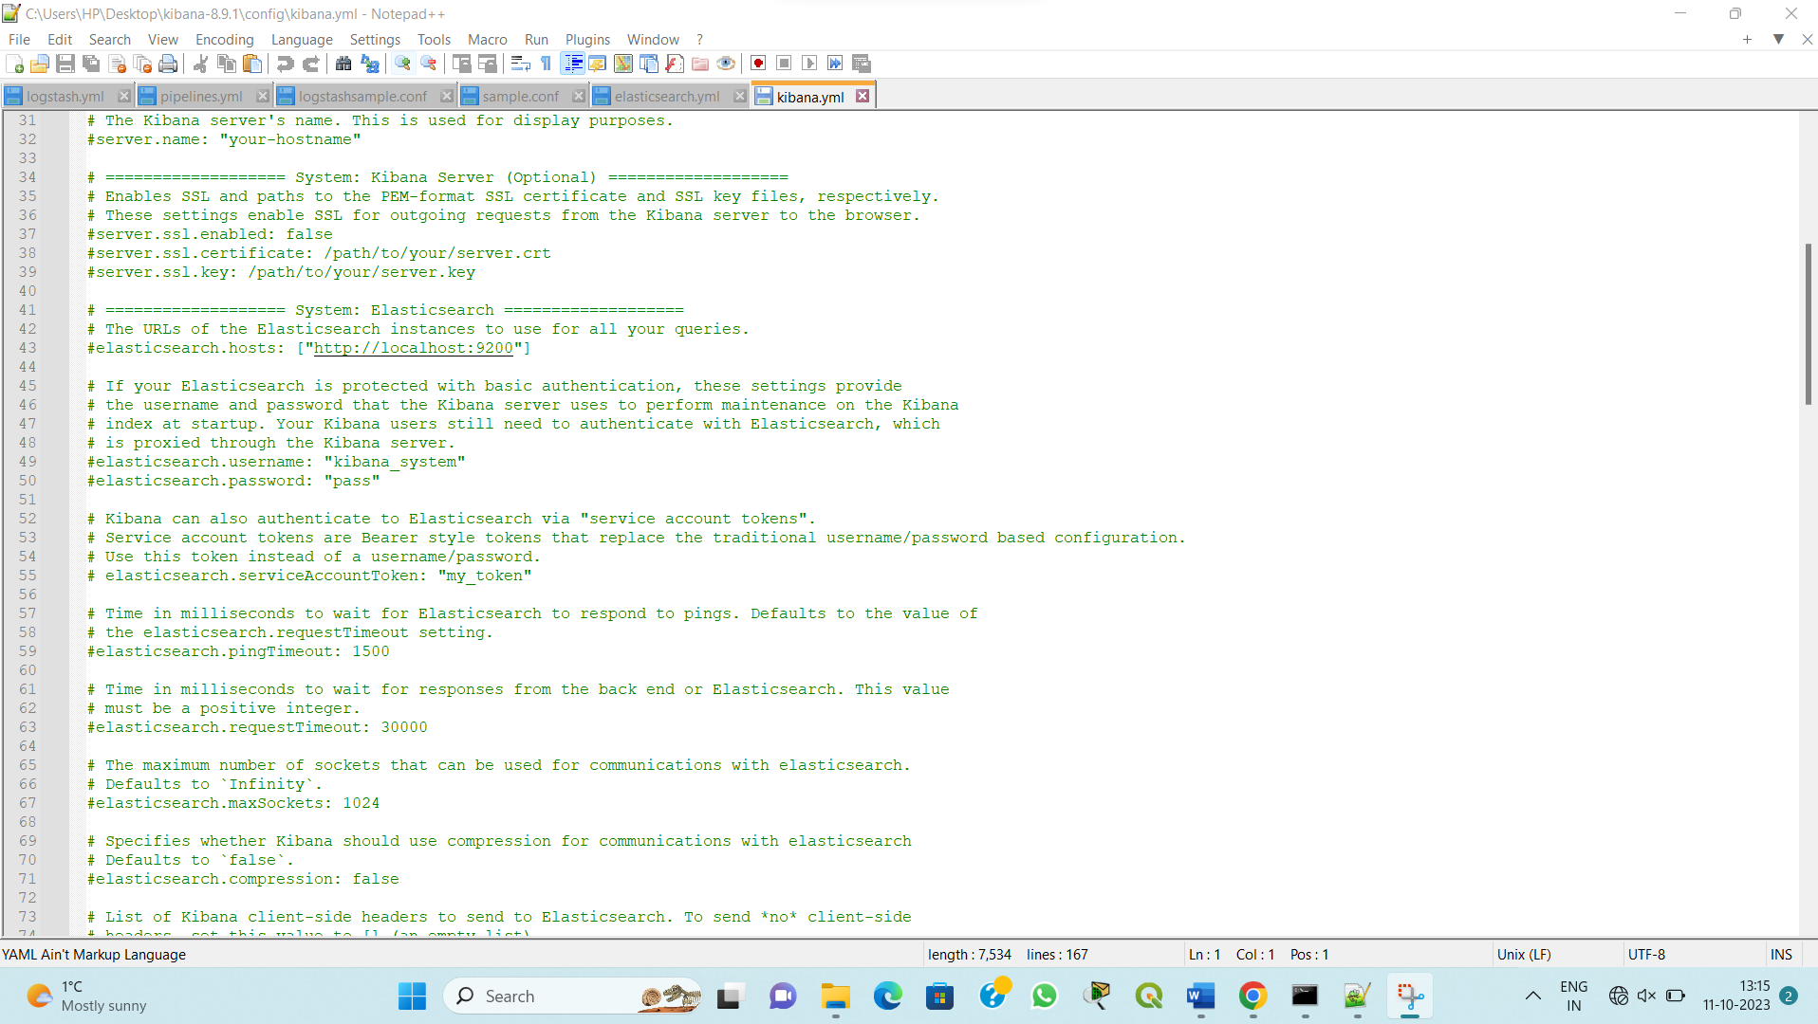

1. K
2. The bat file of kibana is runned to start the kibana server along with the code to get started.

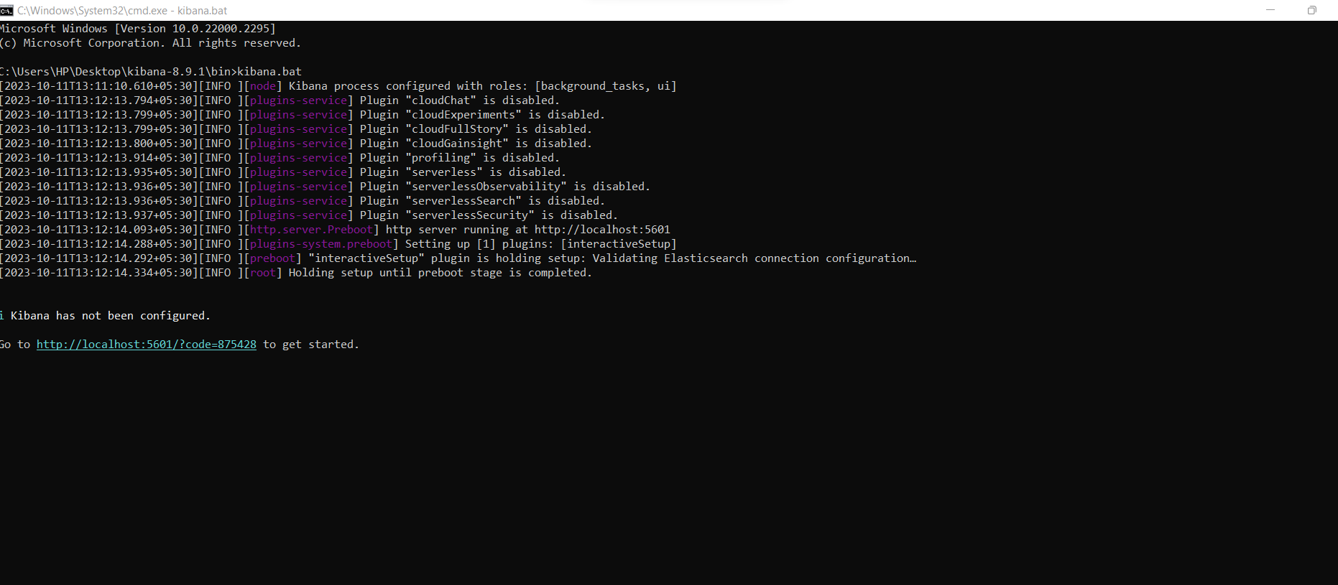

1. The initial configuration of kibana is done by the server itself based on configuration scripts.

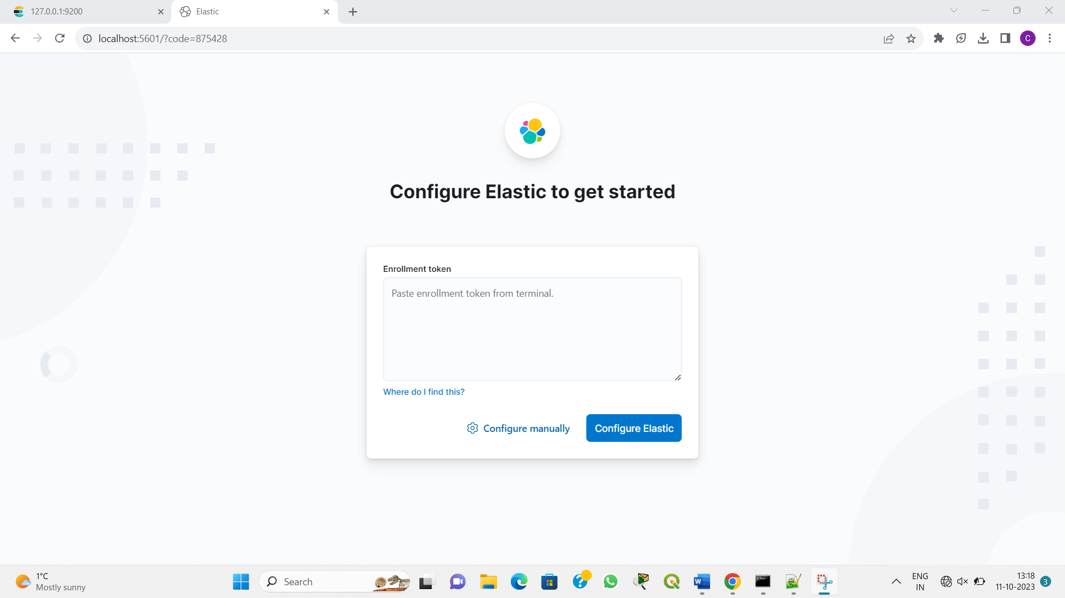

1. To avoid generating the code and configuring it each and everytime in kibana, the enrolment token is generated from elasticsearch with validity of 30 mins.

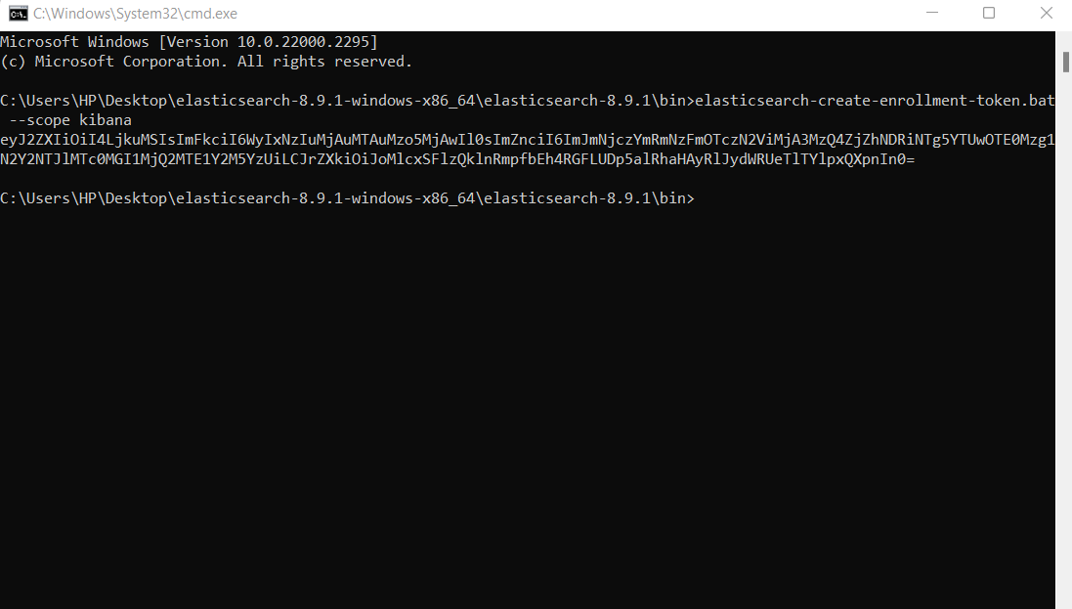

1. The final configuration and loading of APIs is done to start the server with full capabilities.

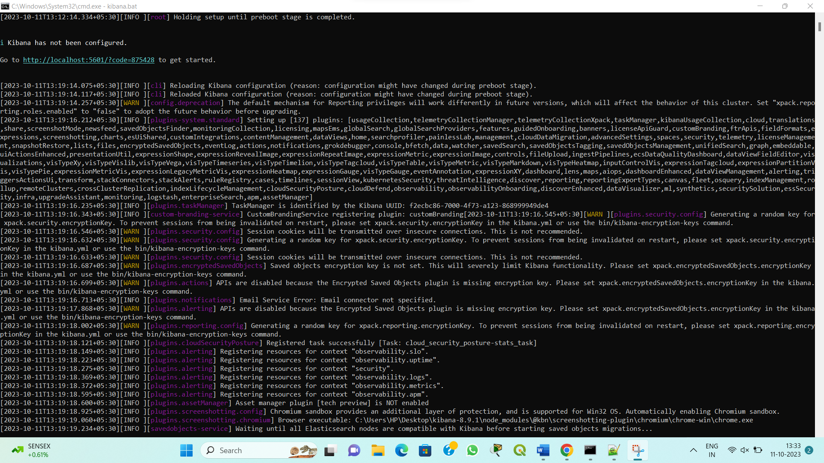

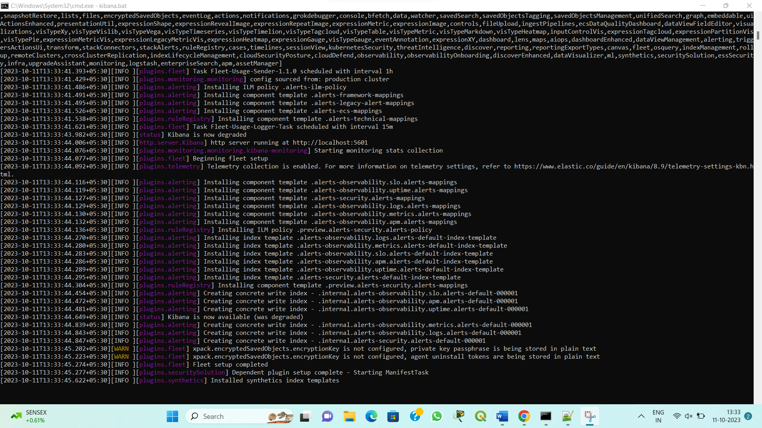

1. The server is ready to be configured.

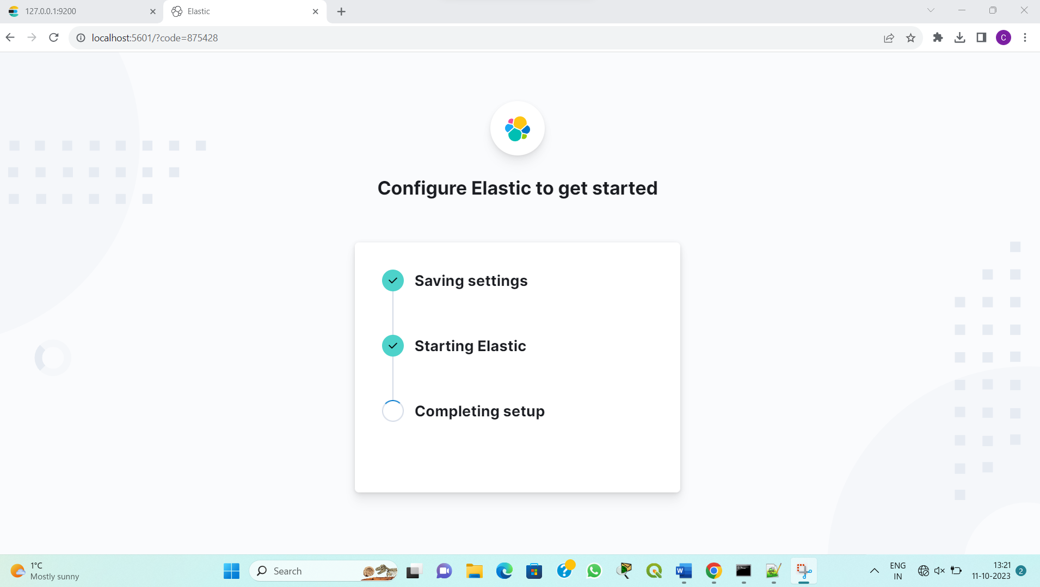

1. The kibana then runs on localhost:5601 with the credentials same as that of elasticsearch.

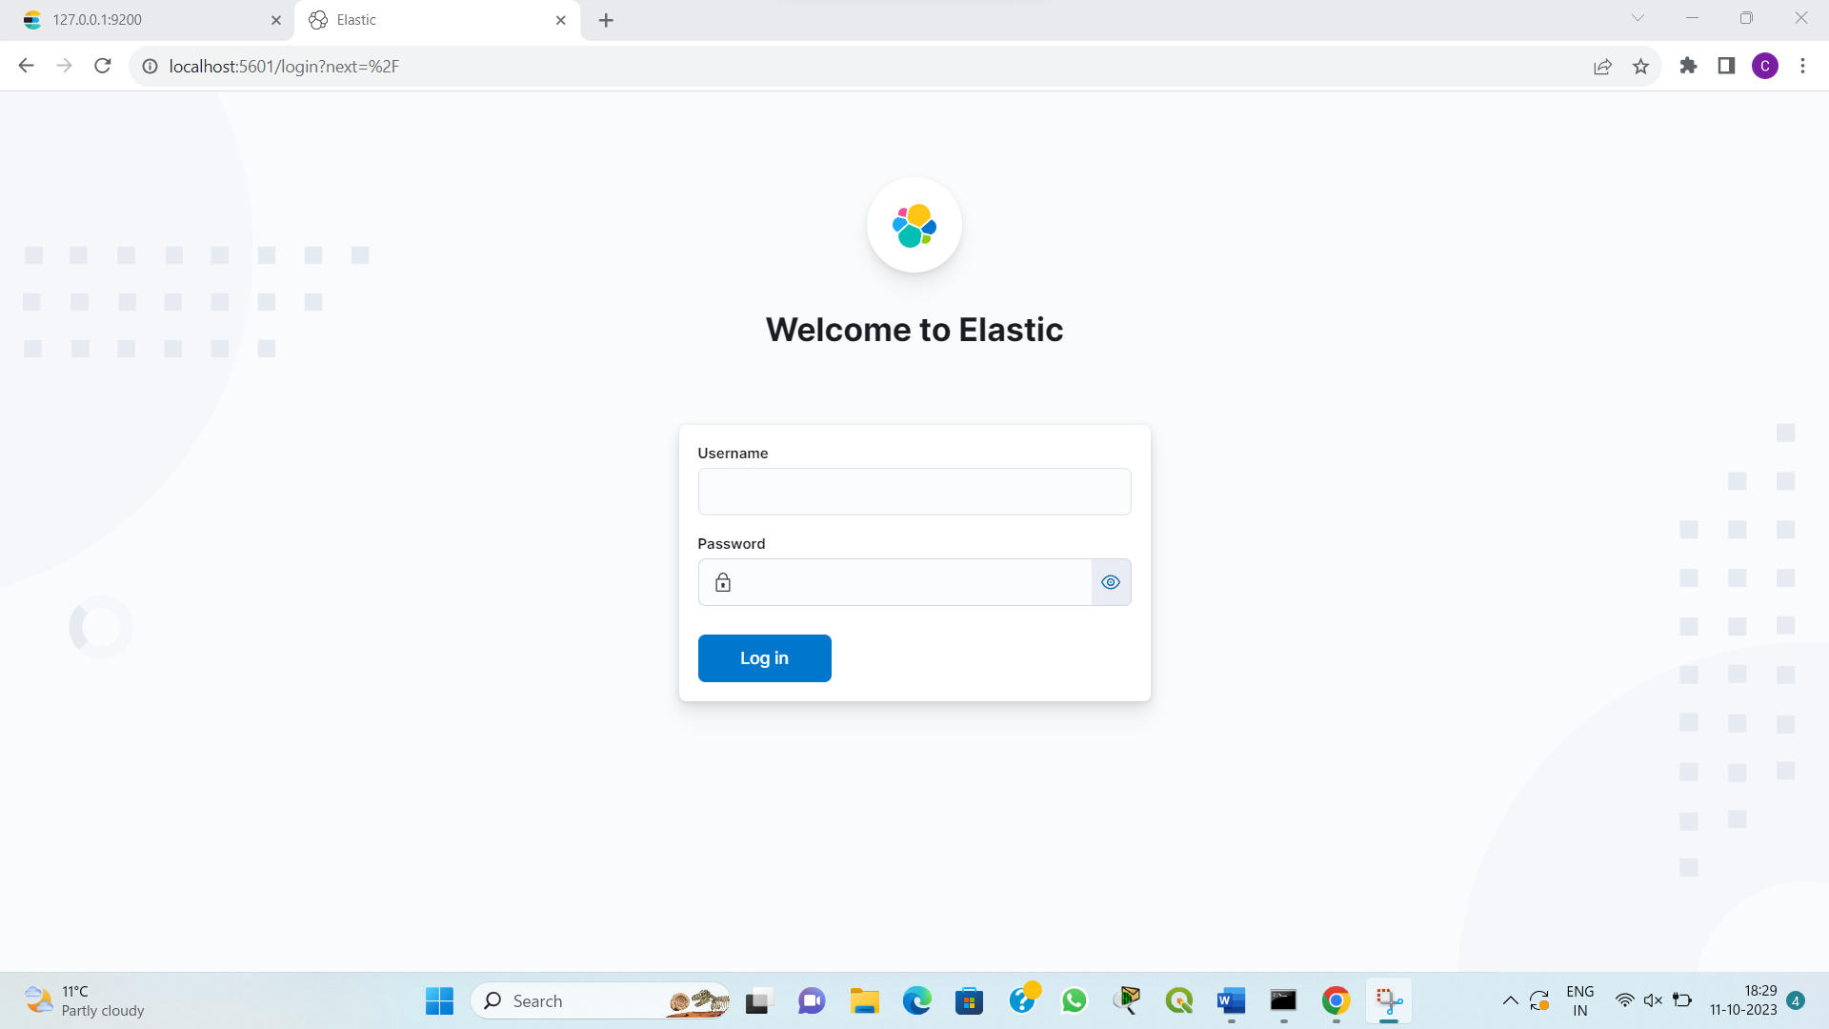

1. The first view of kibana interface.



1. The interface is set to provide search, observe, security and analytic functions now.

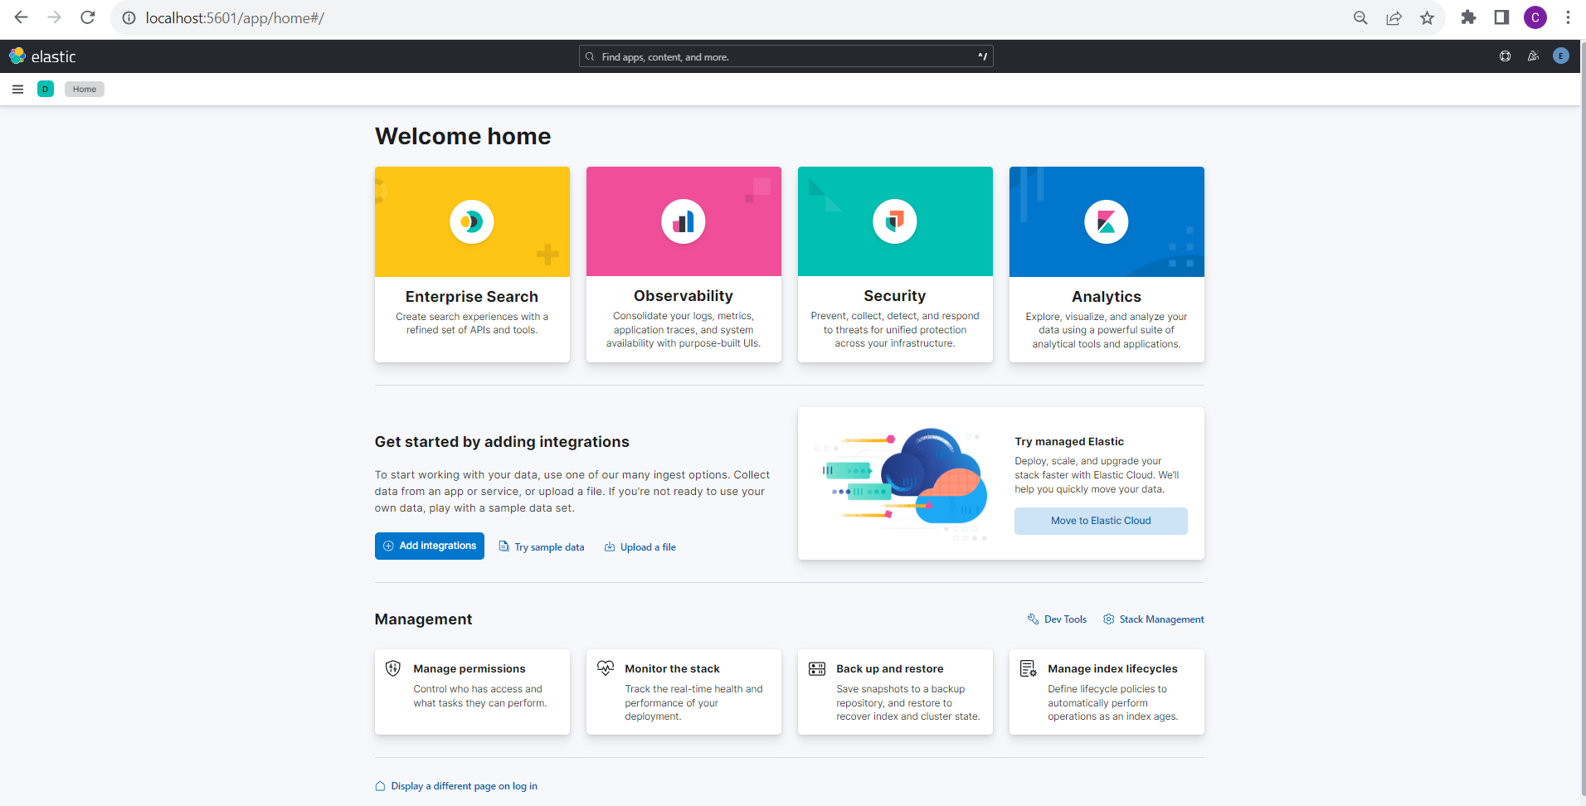

1. The logstash configuration file is then run along the logstash script by running ‘logstash -f “\filepath\logconfigfile’

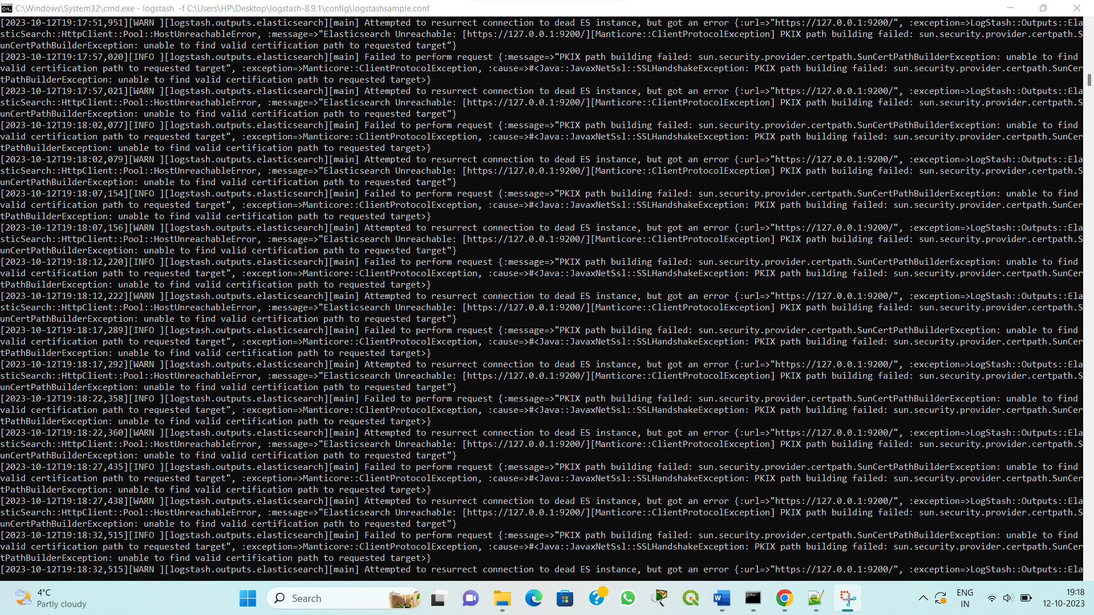

1. A sample logstash config file used to run the current logstash script.

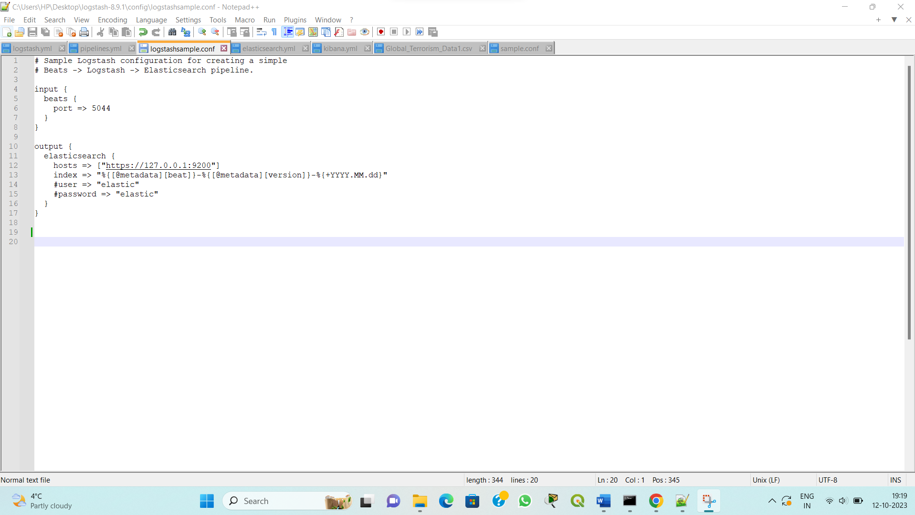

1. The pipeline.yml file of elasticsearch is edited with the path to logstash config file to integrate both of them.

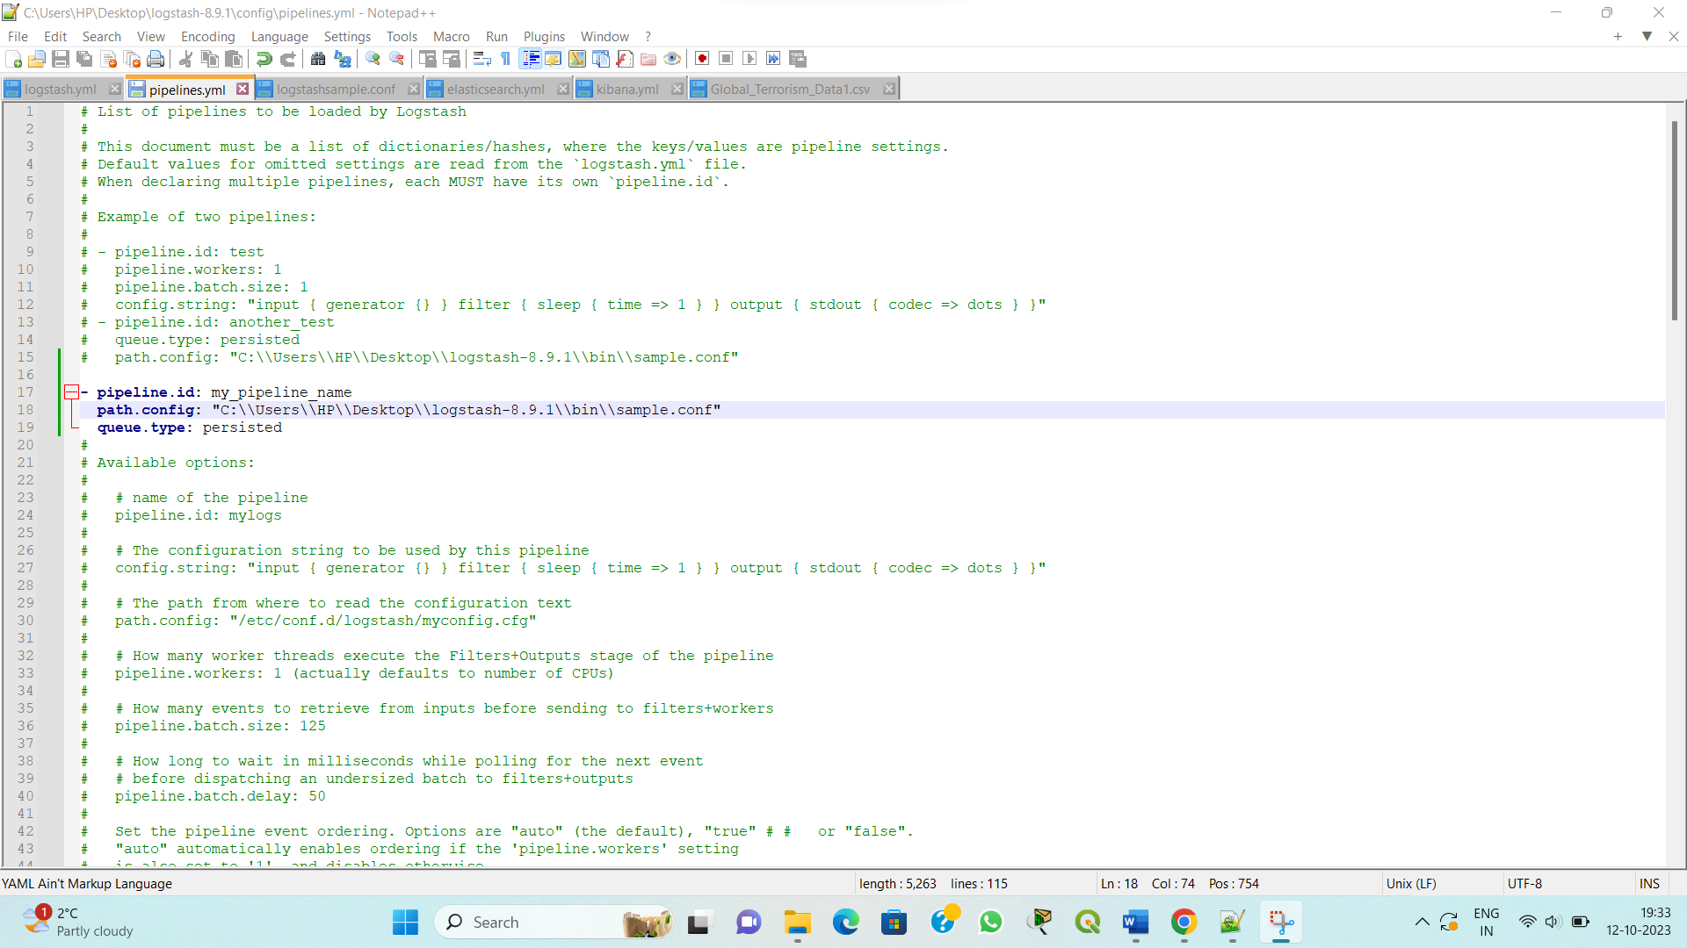

1. The logstash.yml file holding the api, security settings.

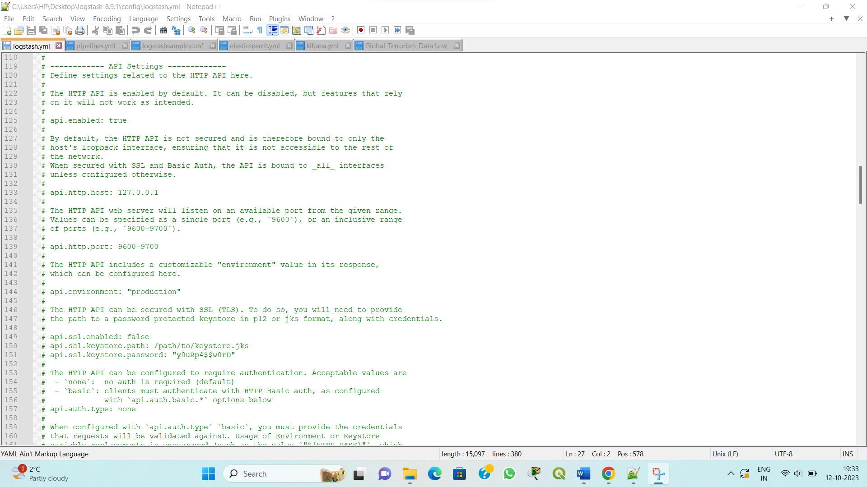

1. The sample data provided to analyse.

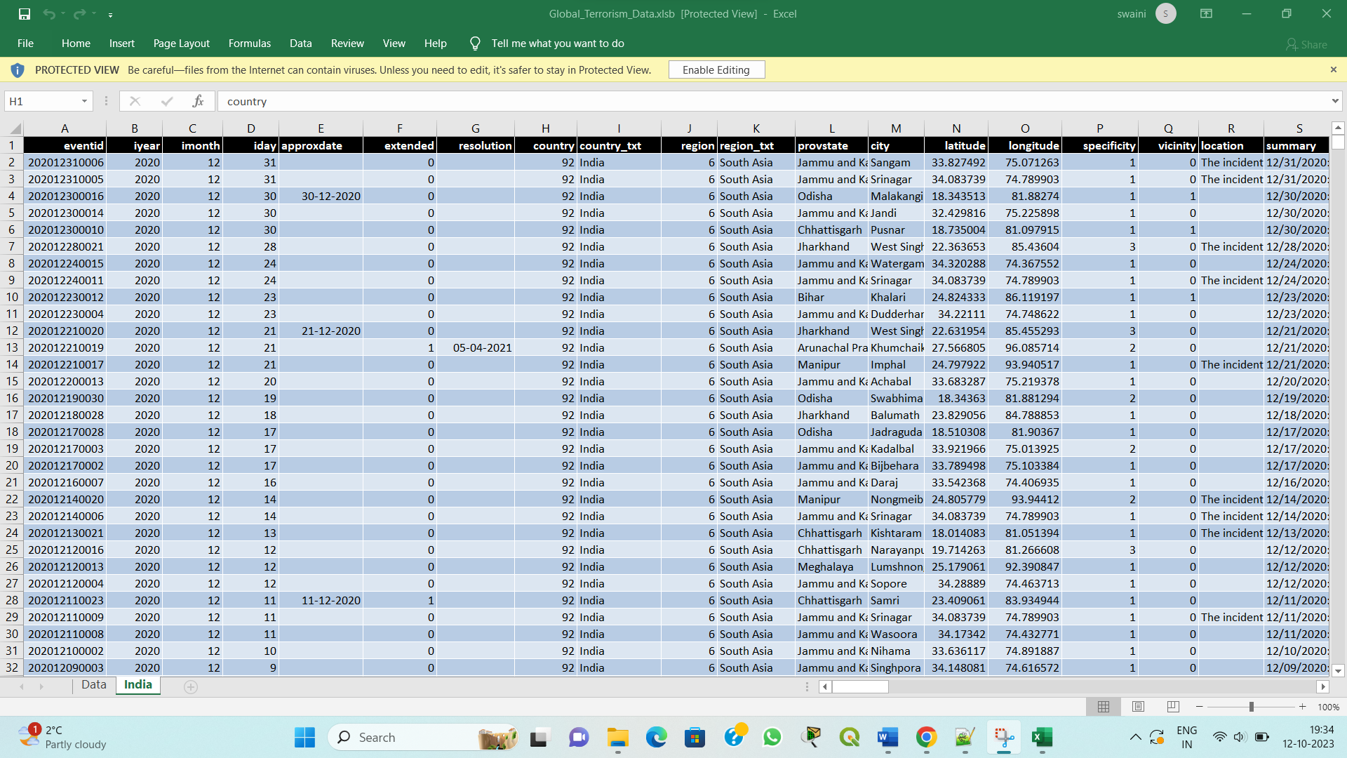

1. Kibana has limitation to only run json, csv , tsv files.
2. The xlsb file is then converted to csv file by using python scripts.

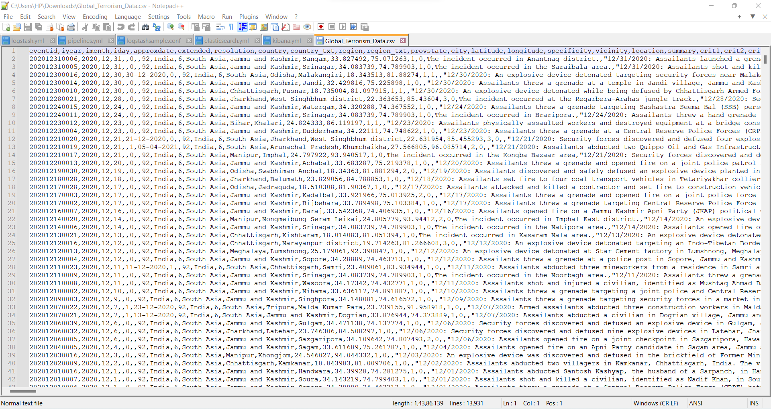

1. The csv file is then imported with ‘,’ being as a delimiter to differentiate between various columns. The summary of first 1000 lines is also given in brief once the data is loaded.

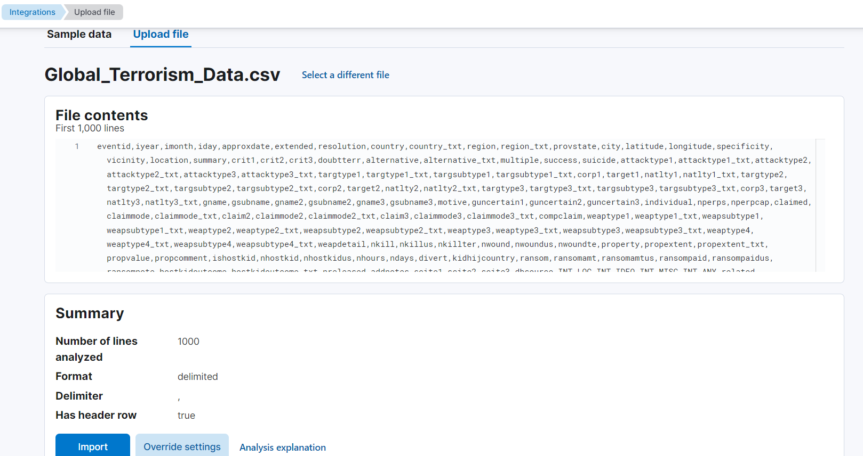

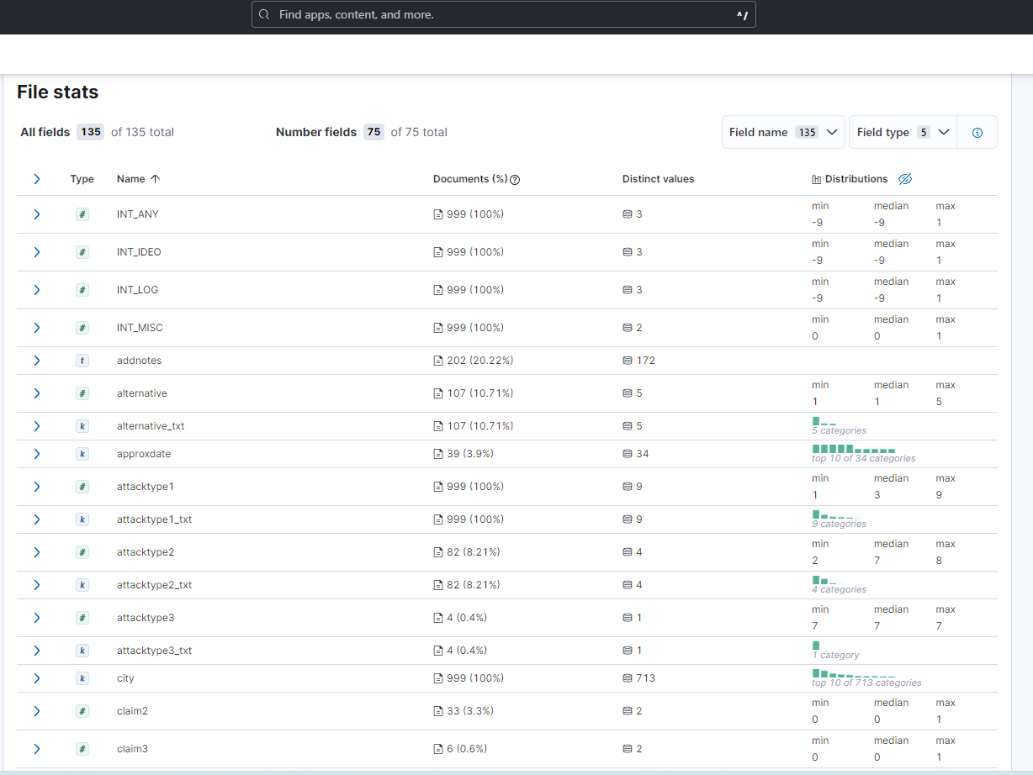

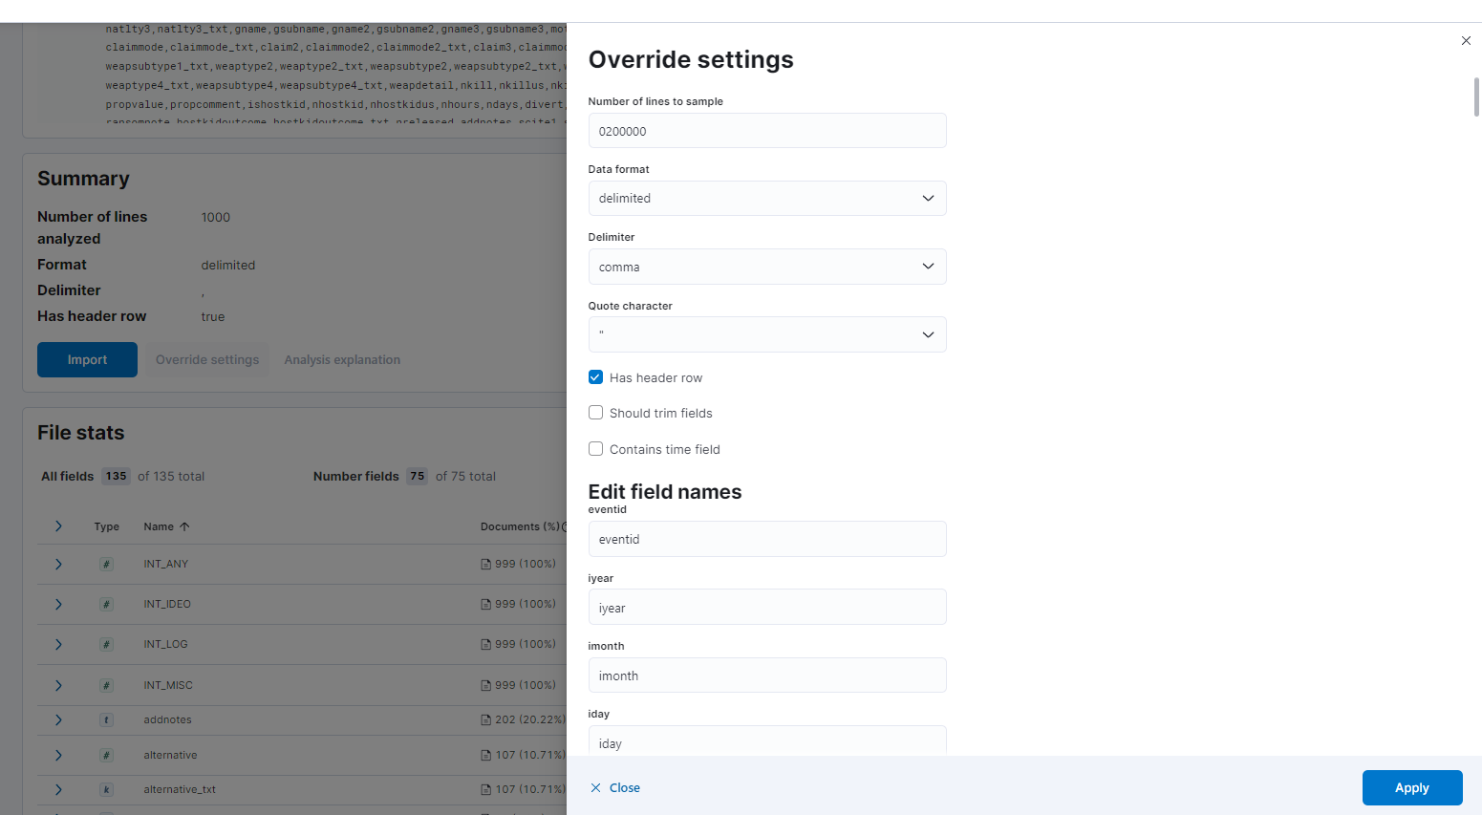

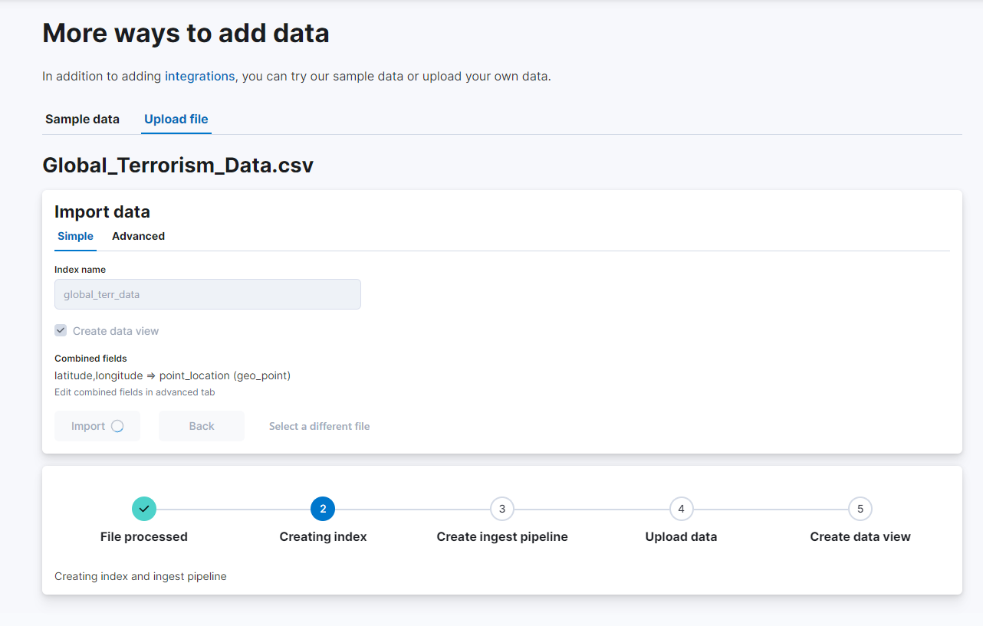

1. Once the file is created, Indexing is done to further analyse the data under an index name. Pipeline is then created, data is uploaded and can be seen under the discover section.

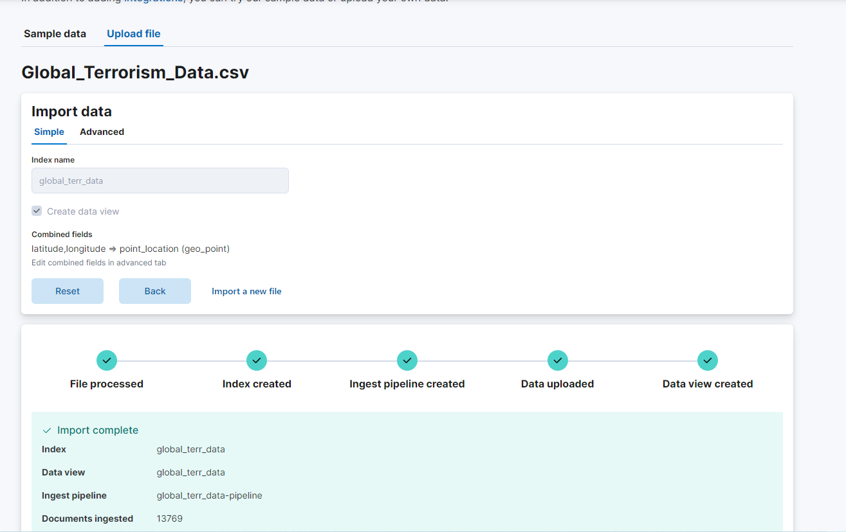

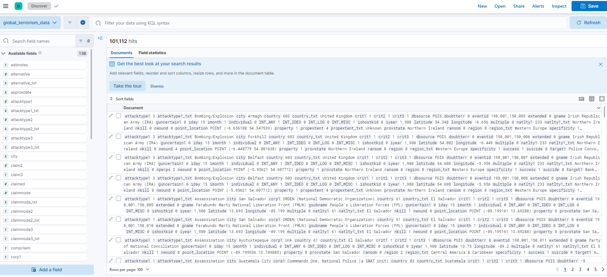

1. The data is then visualised under dashboard and following are the ways to visualise it.

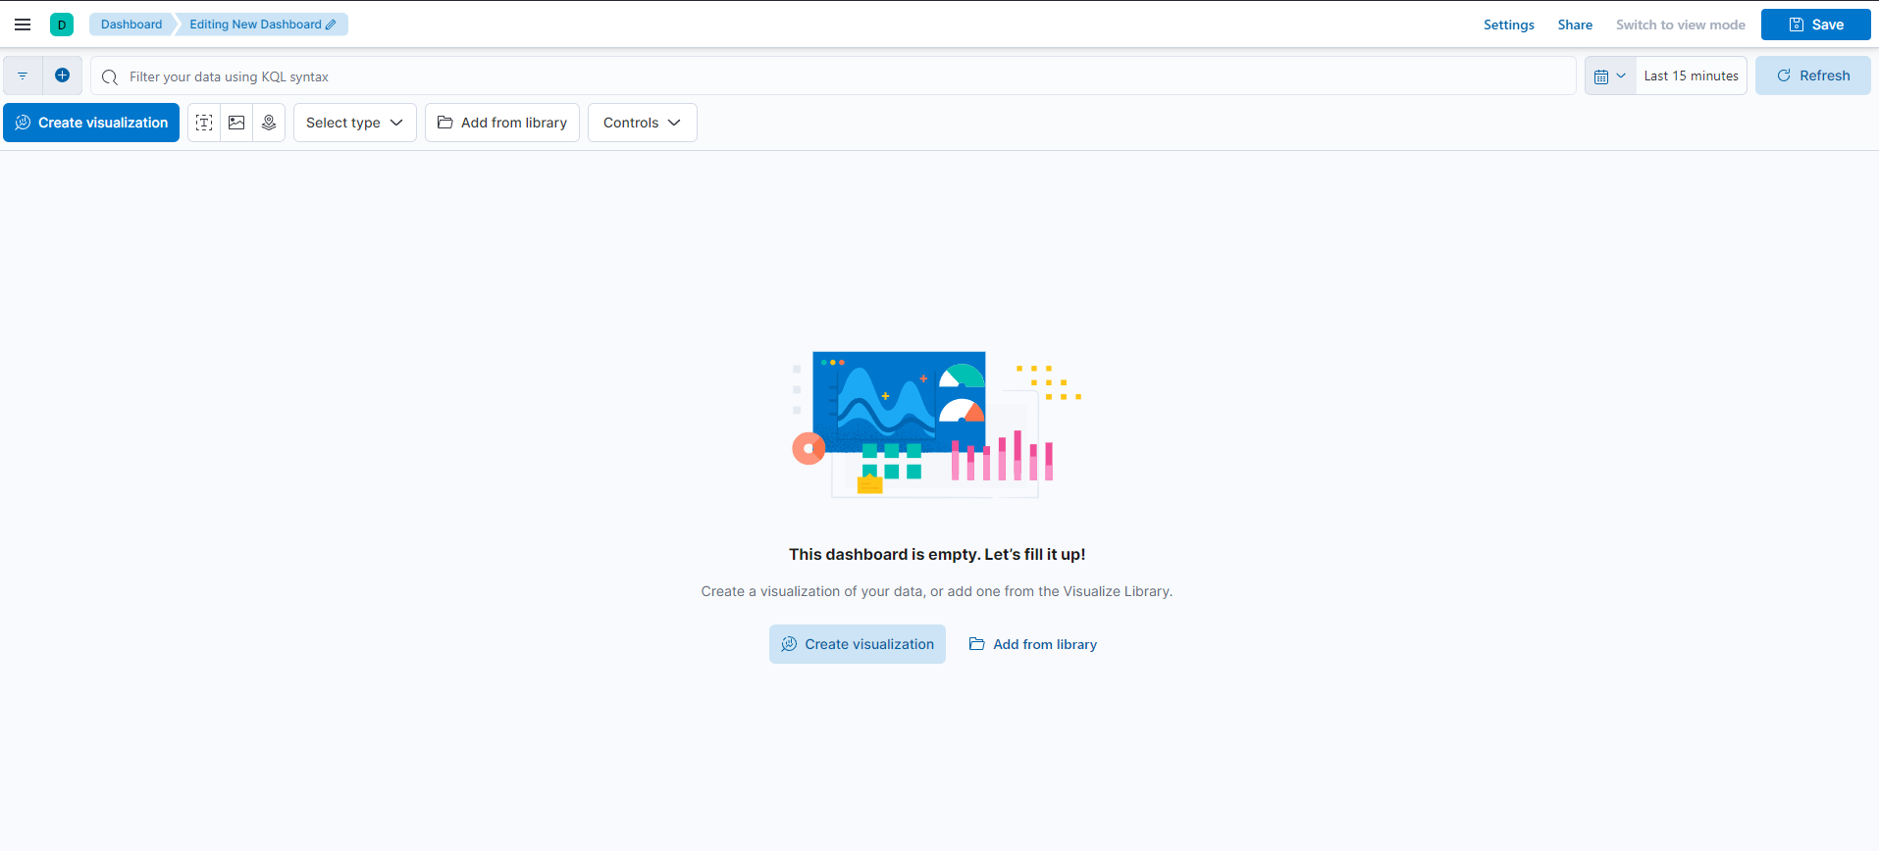

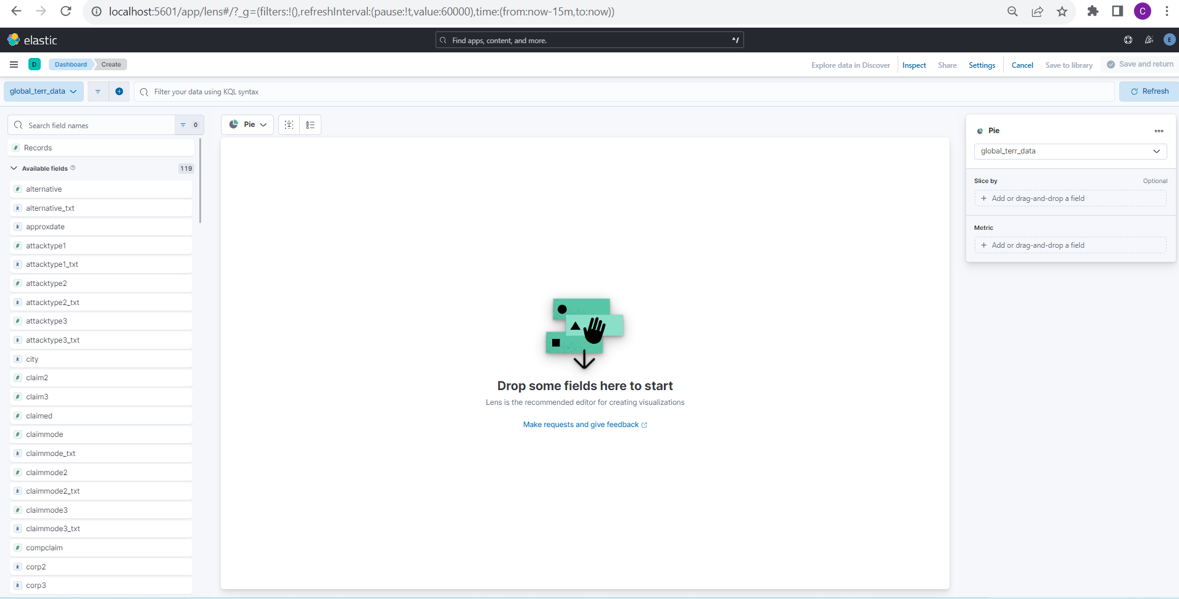

1. **Creating Dashboard.**

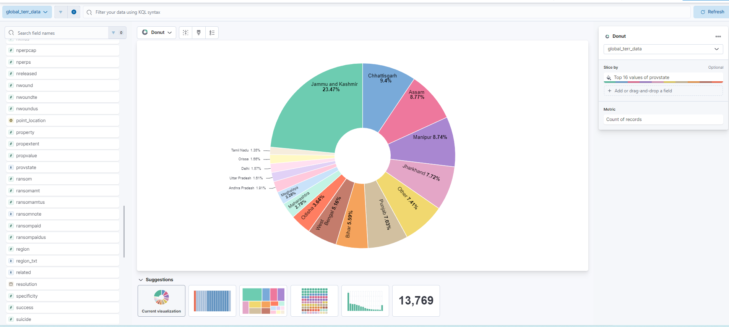

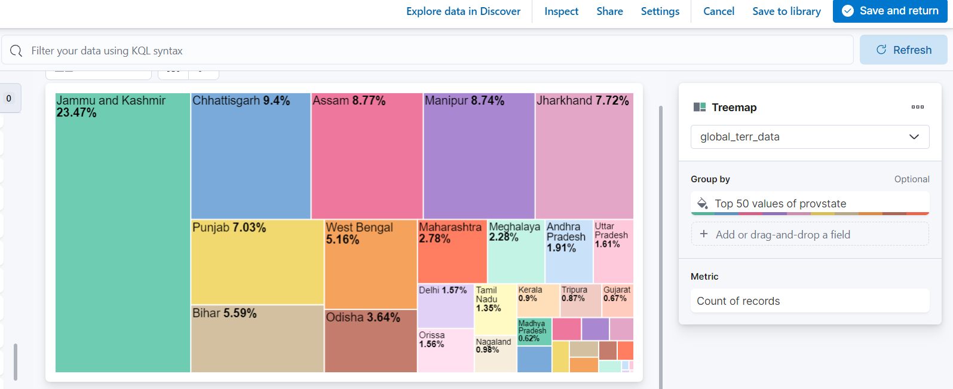

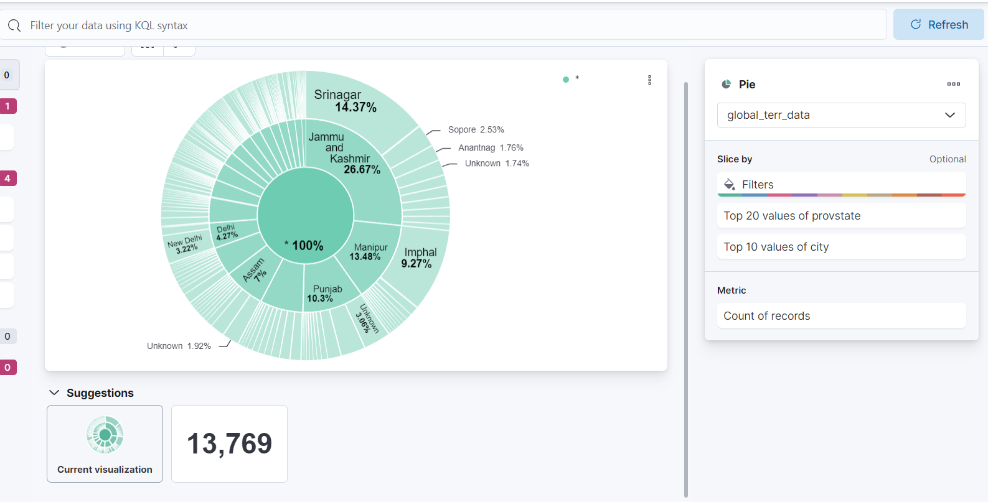

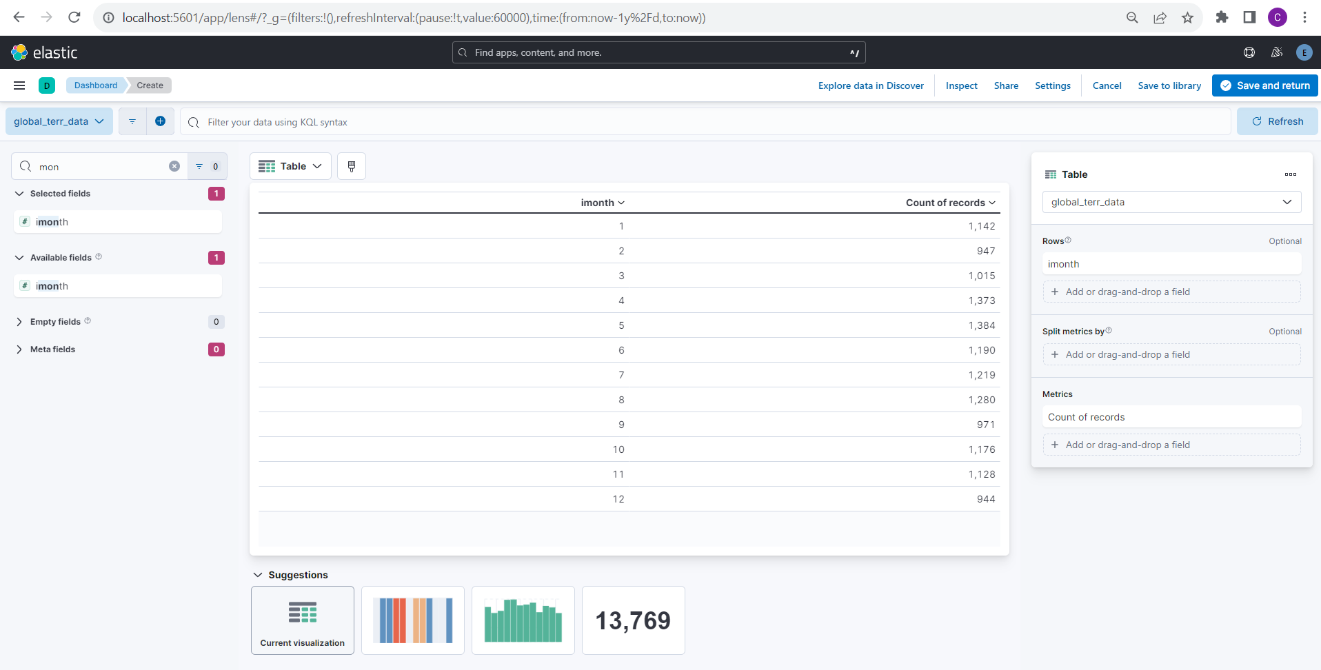

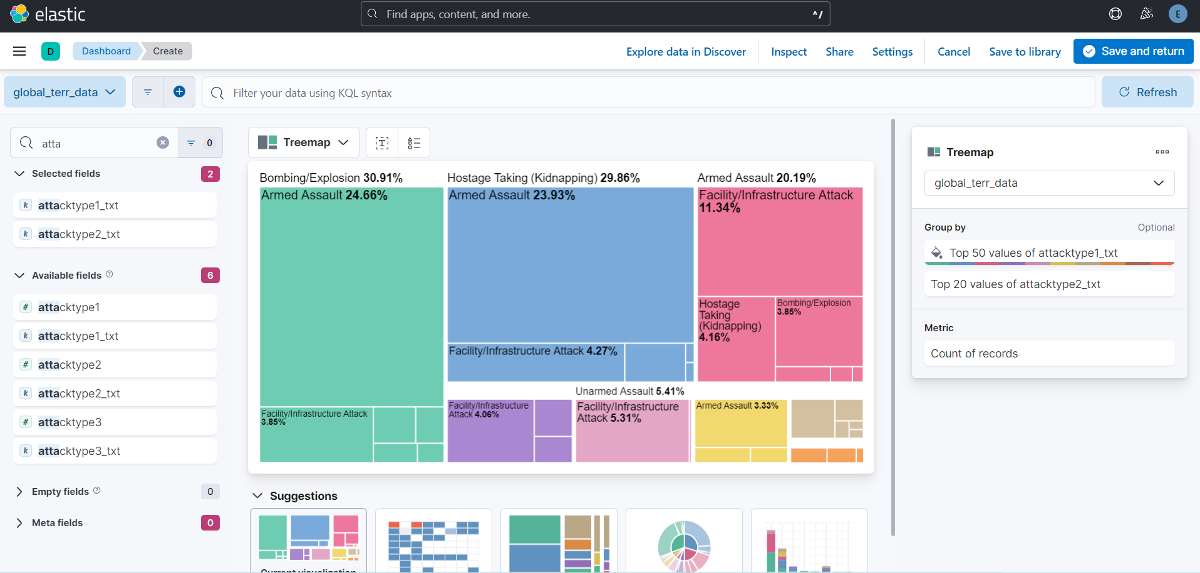

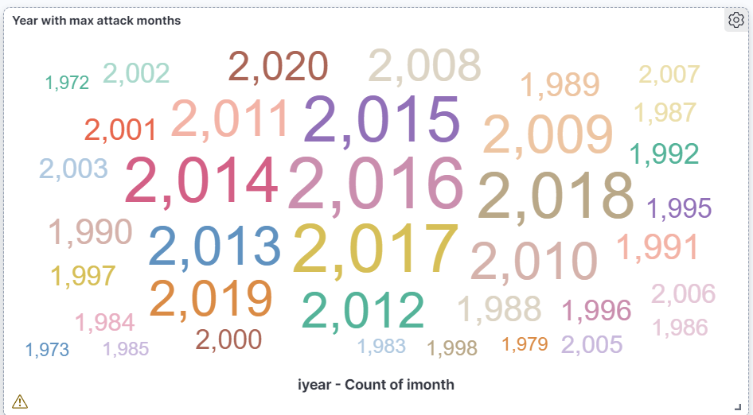

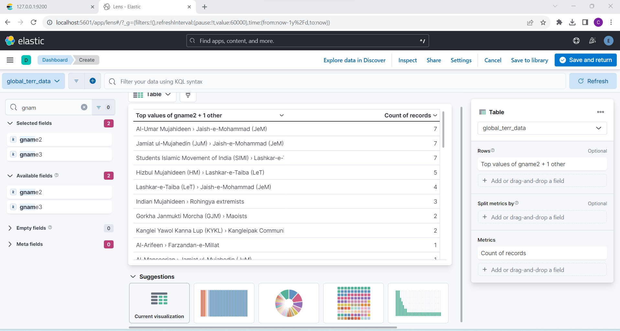

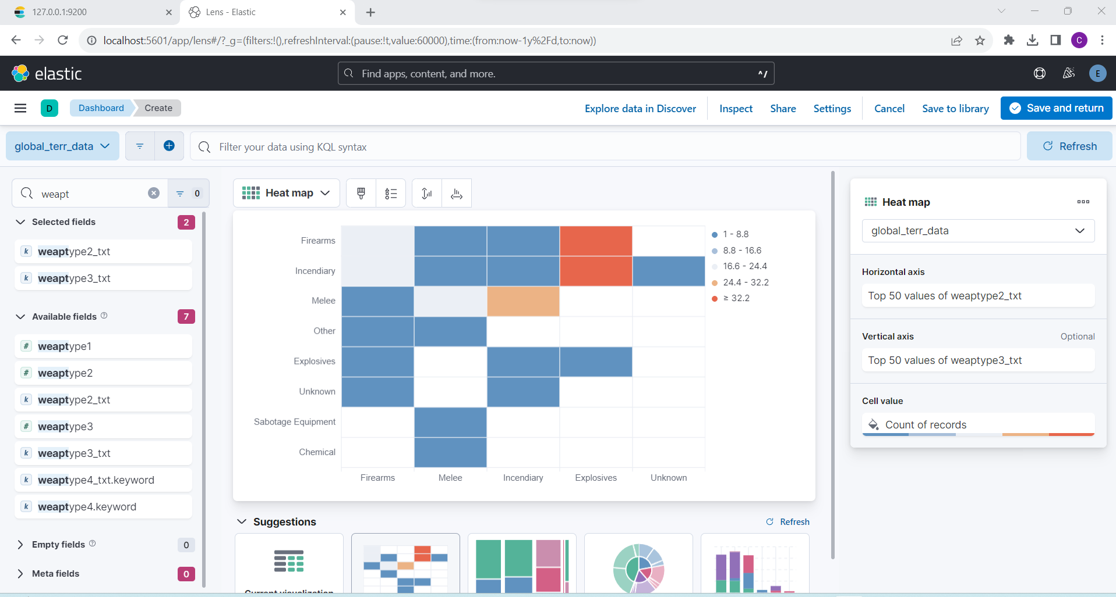

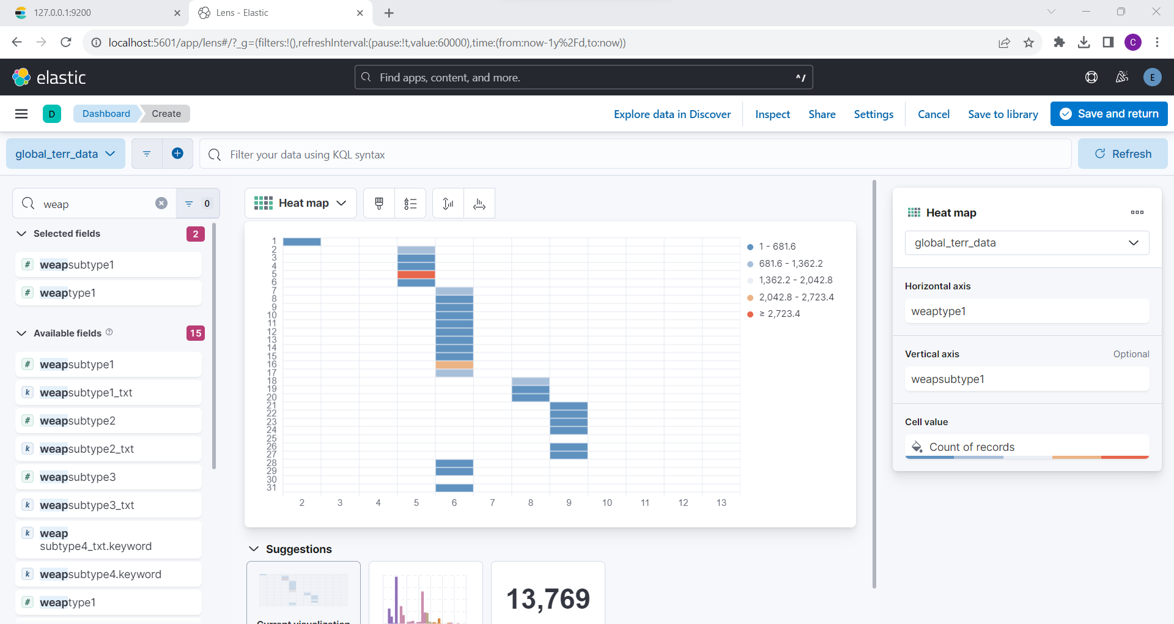

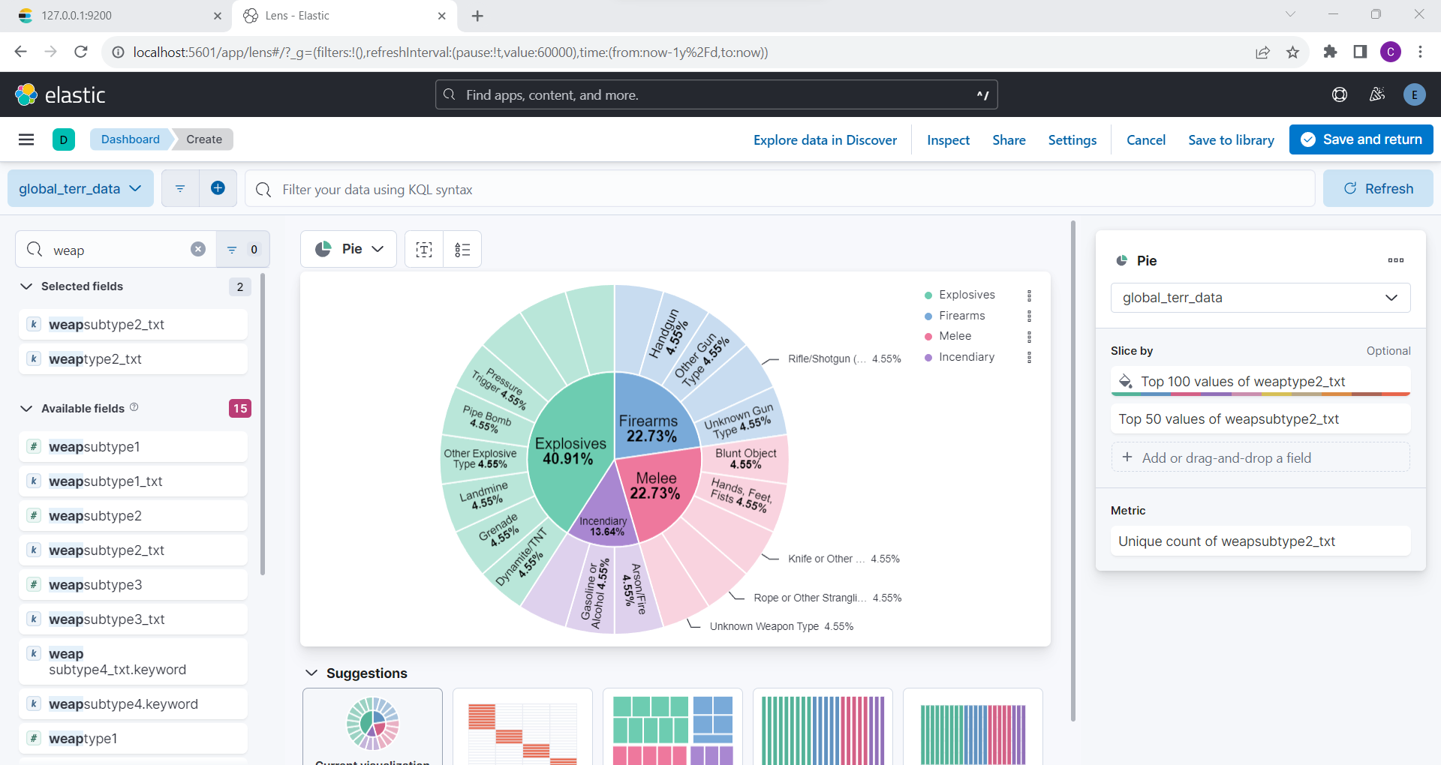

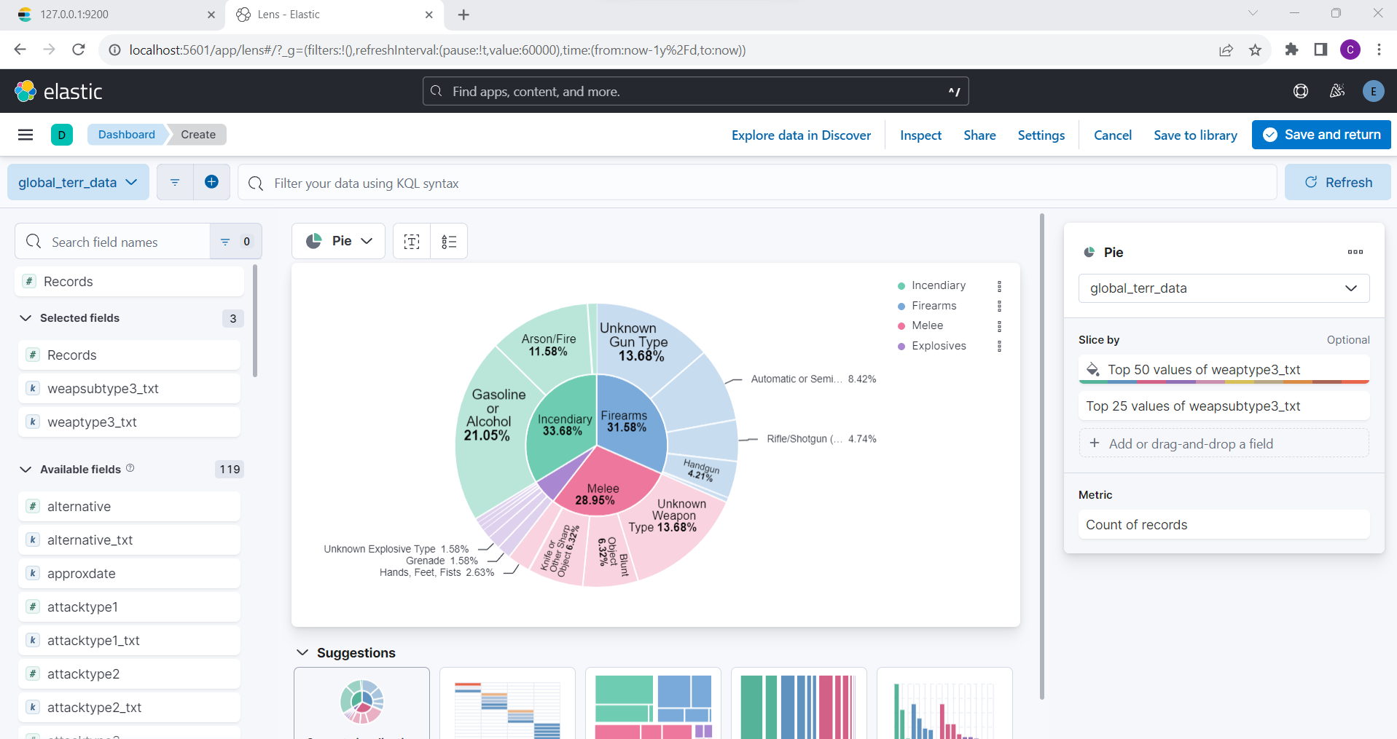

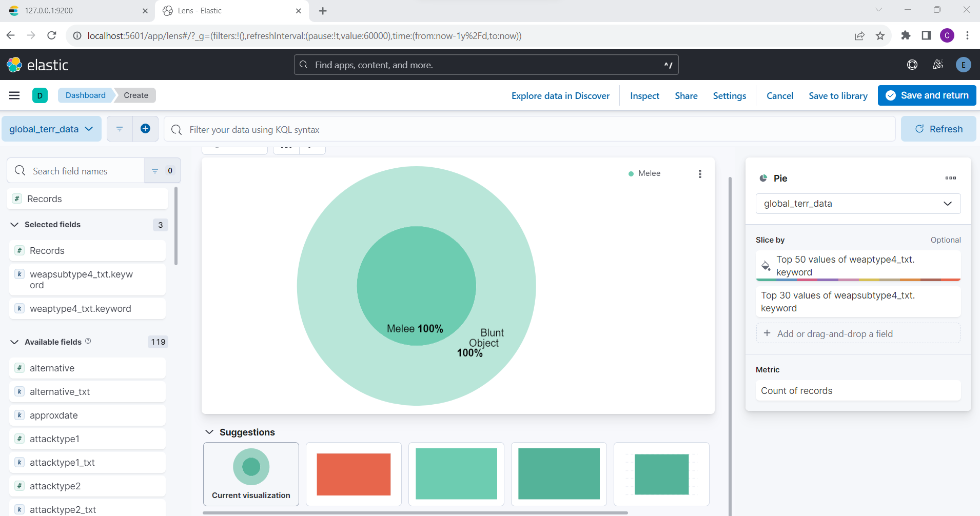

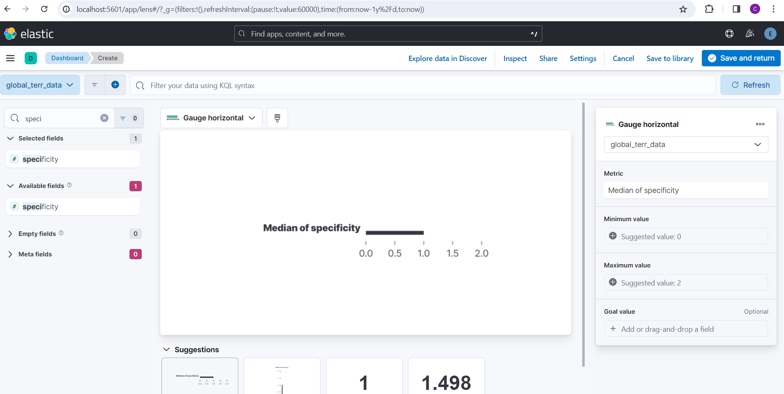

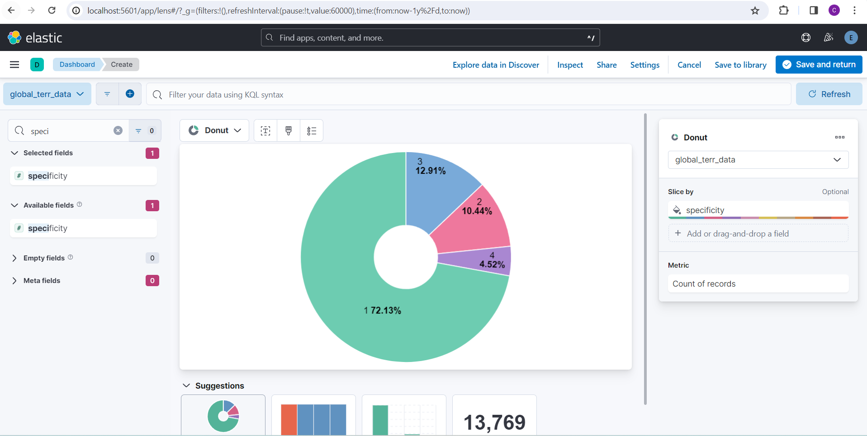

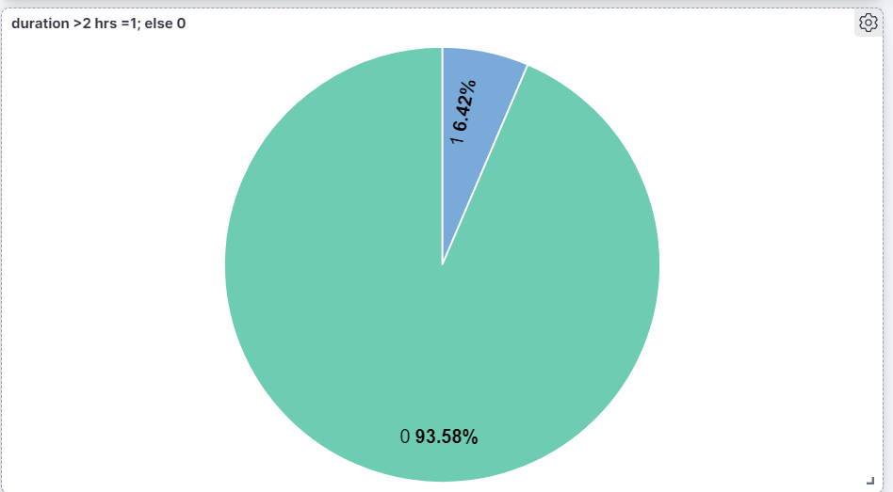

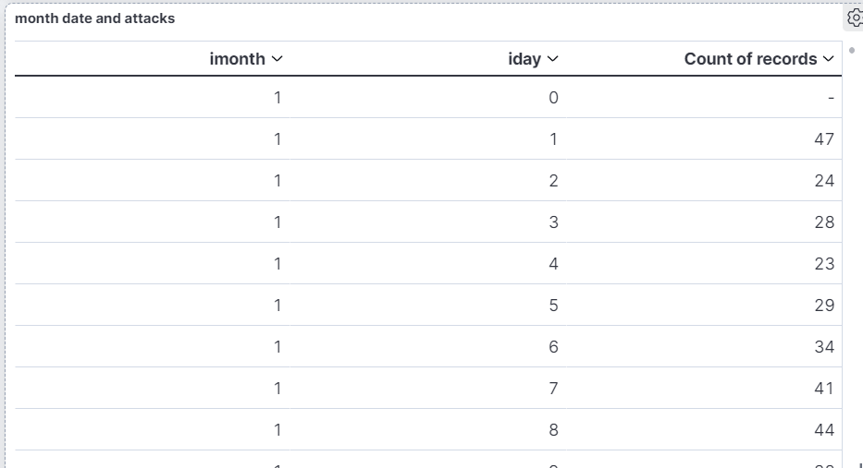

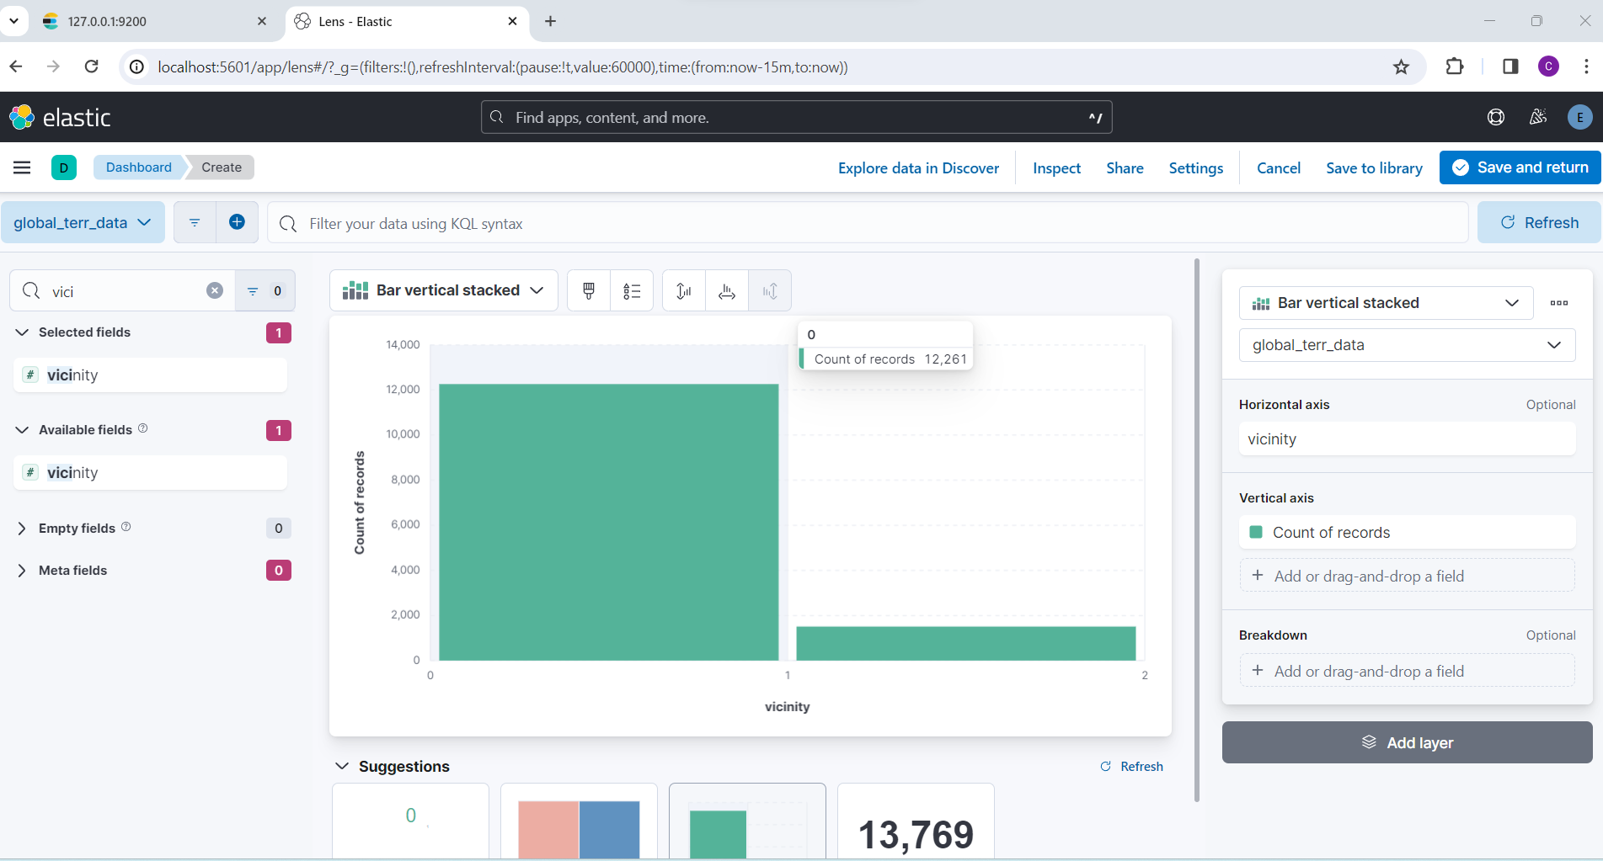

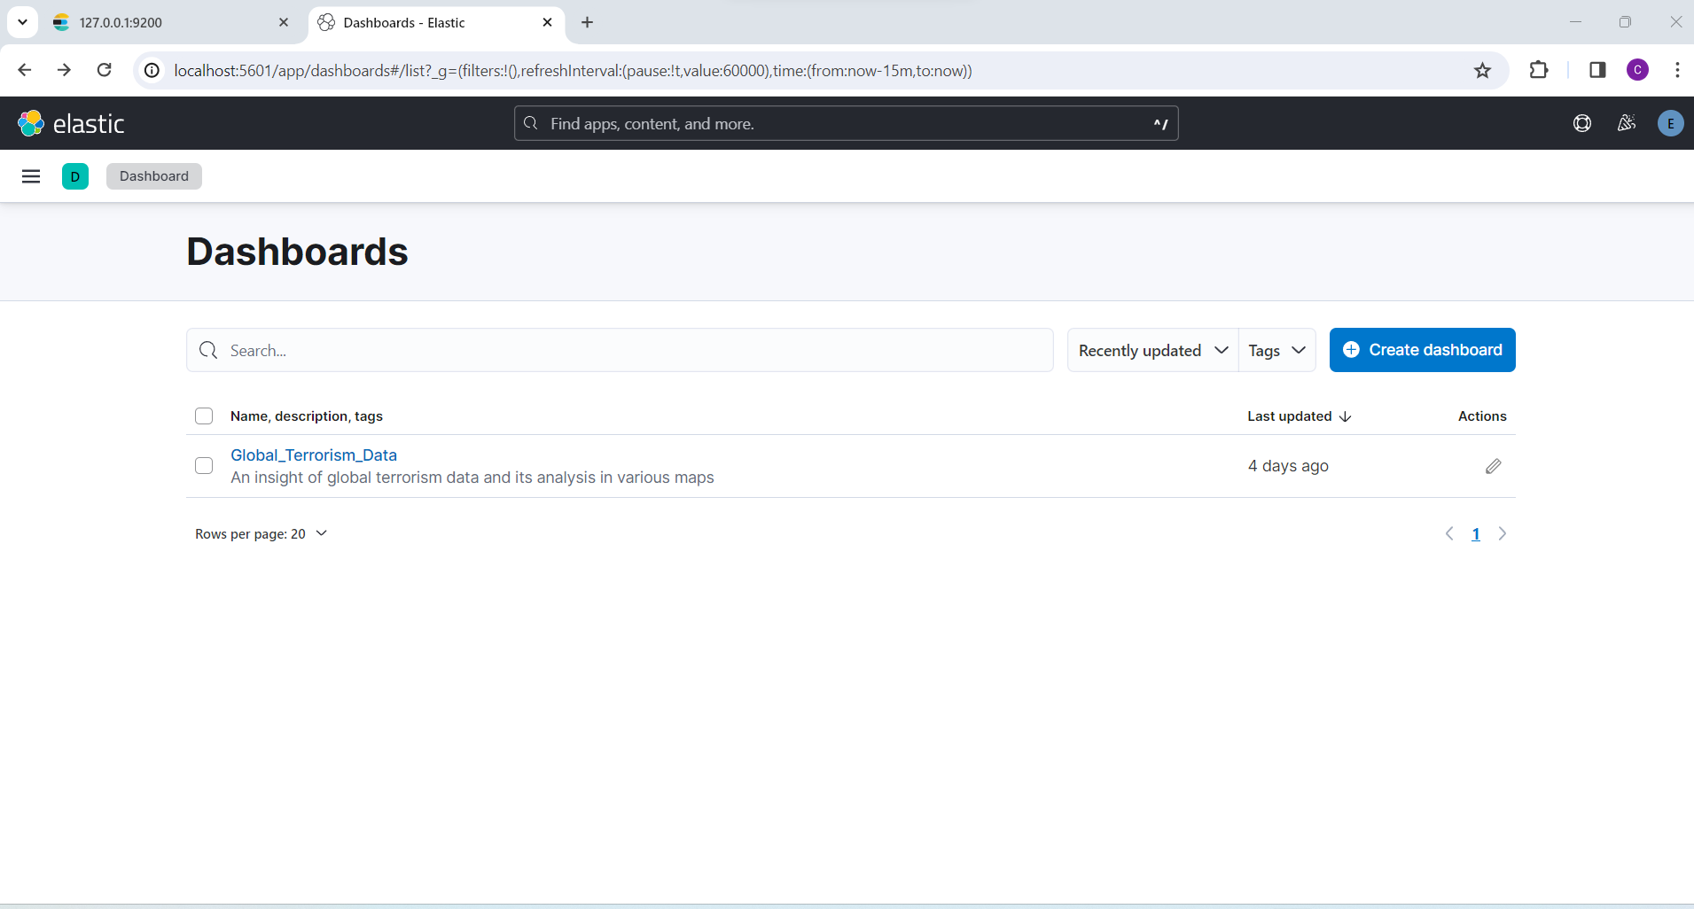

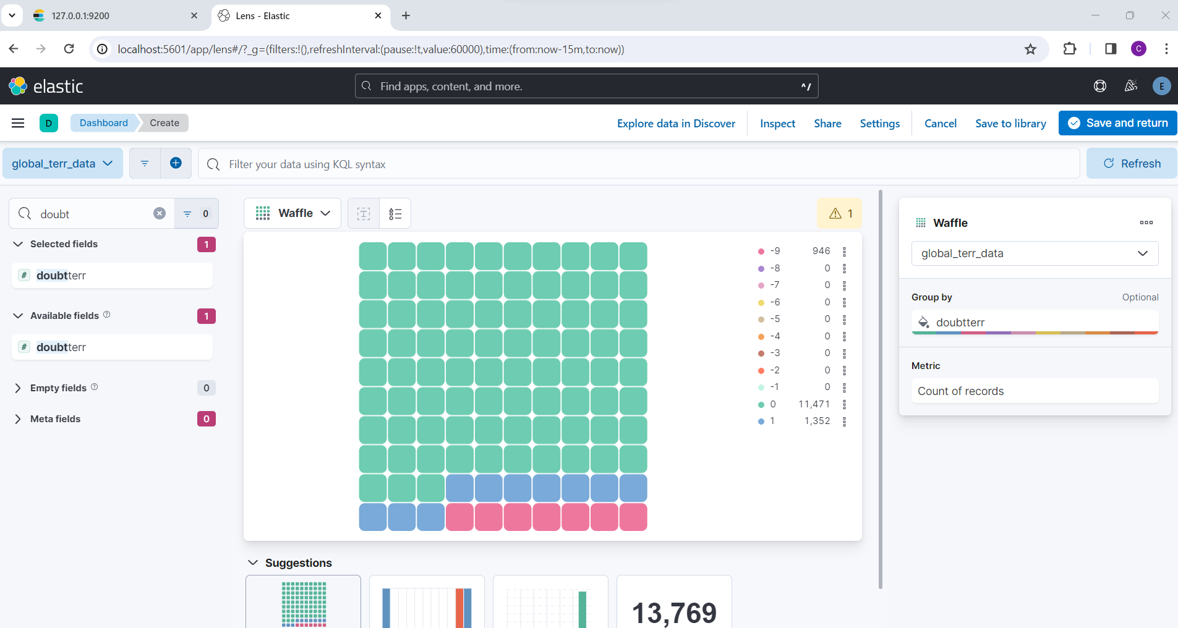

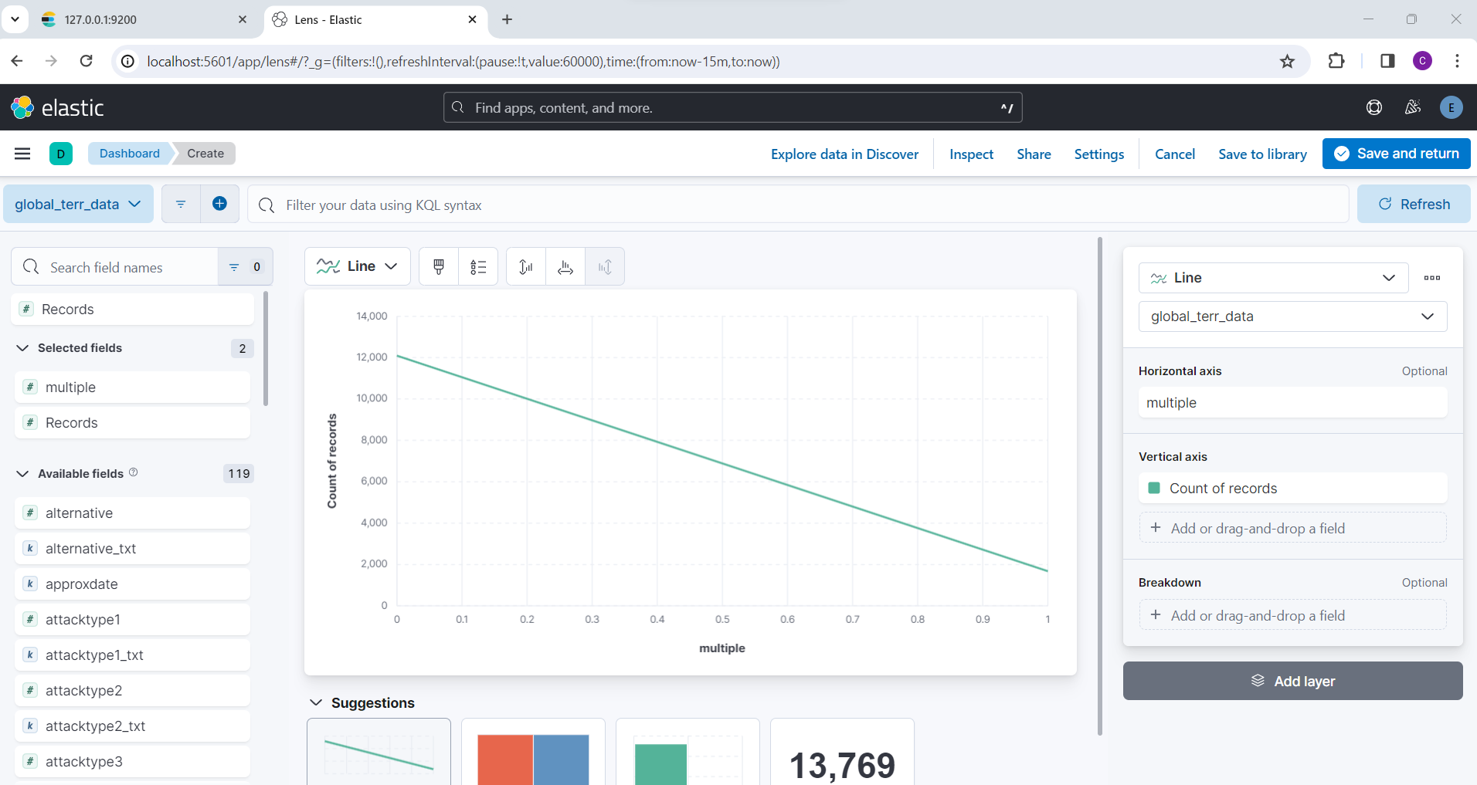

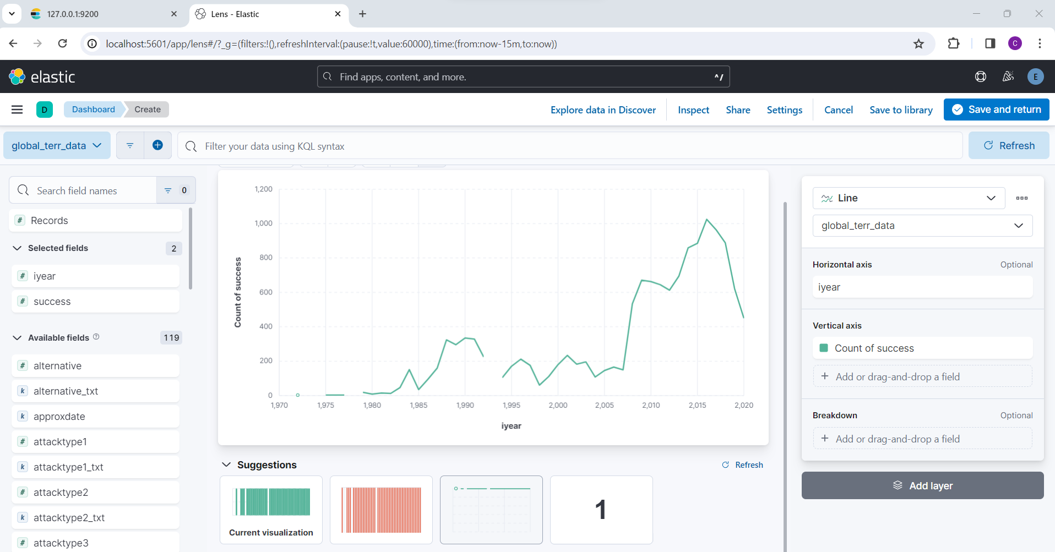

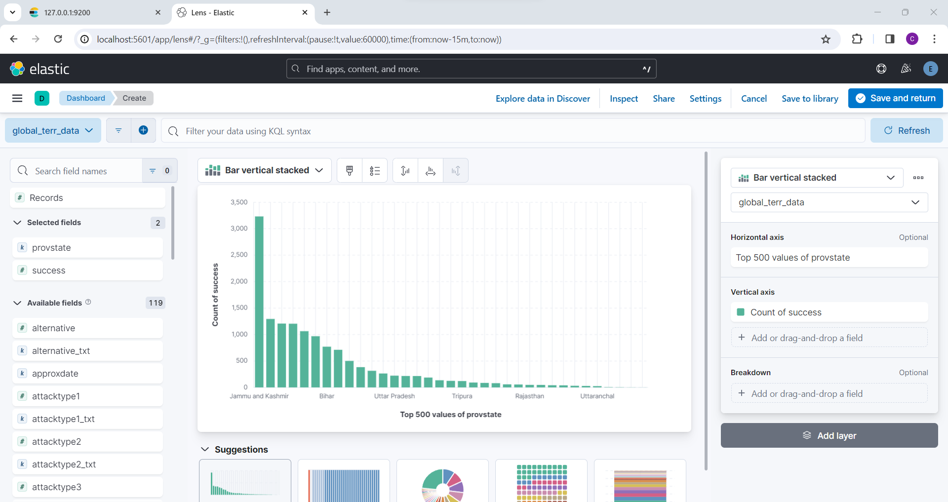

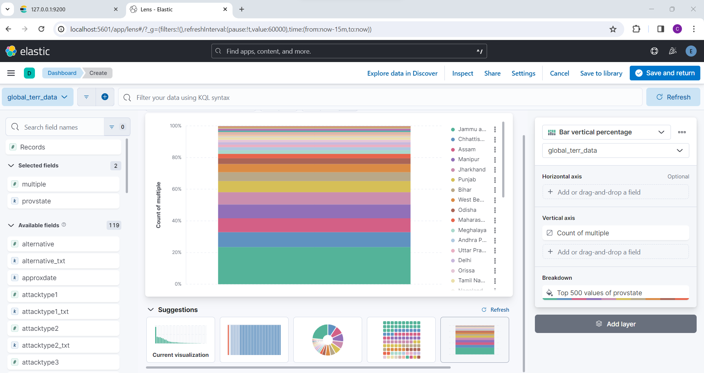

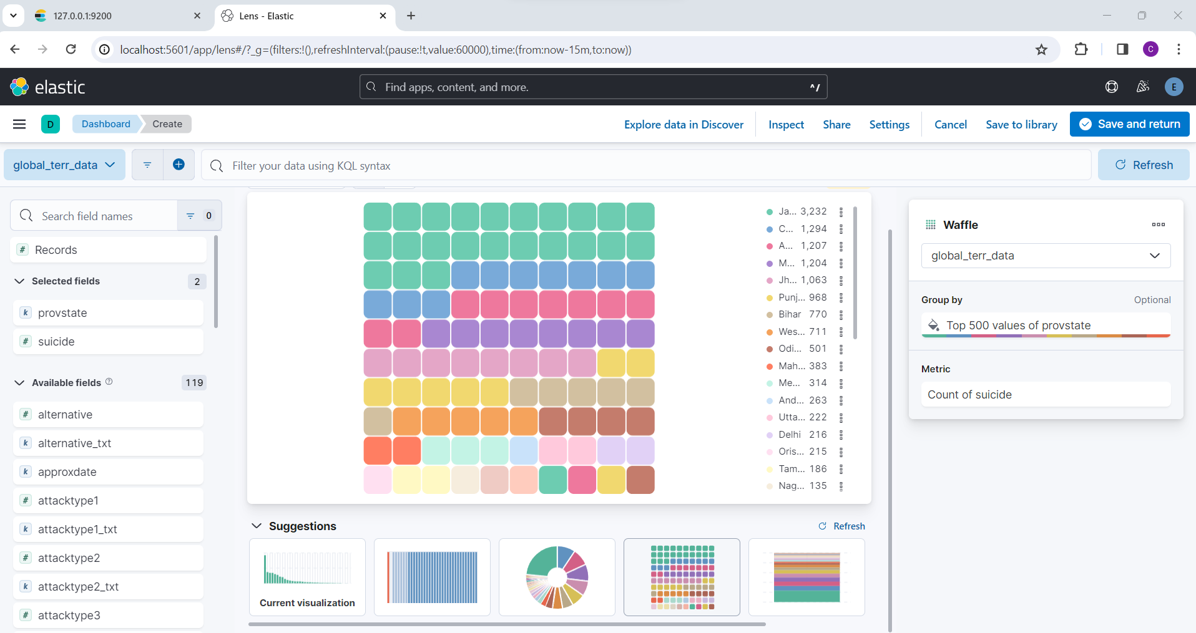

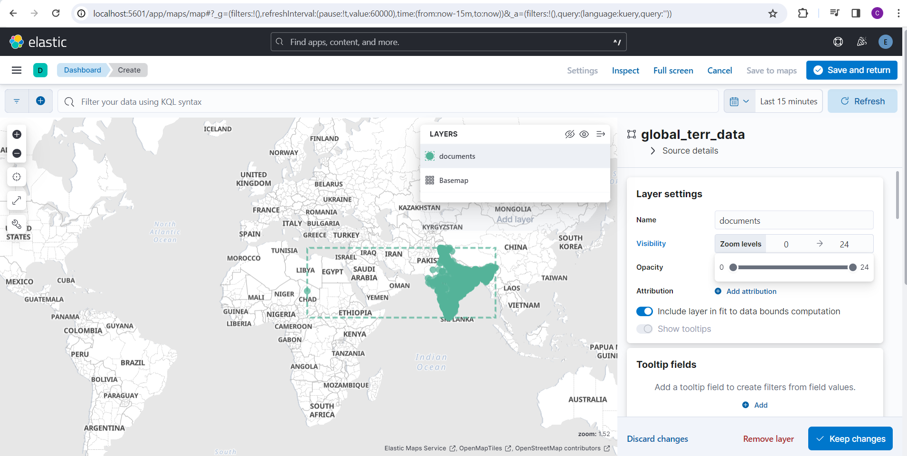

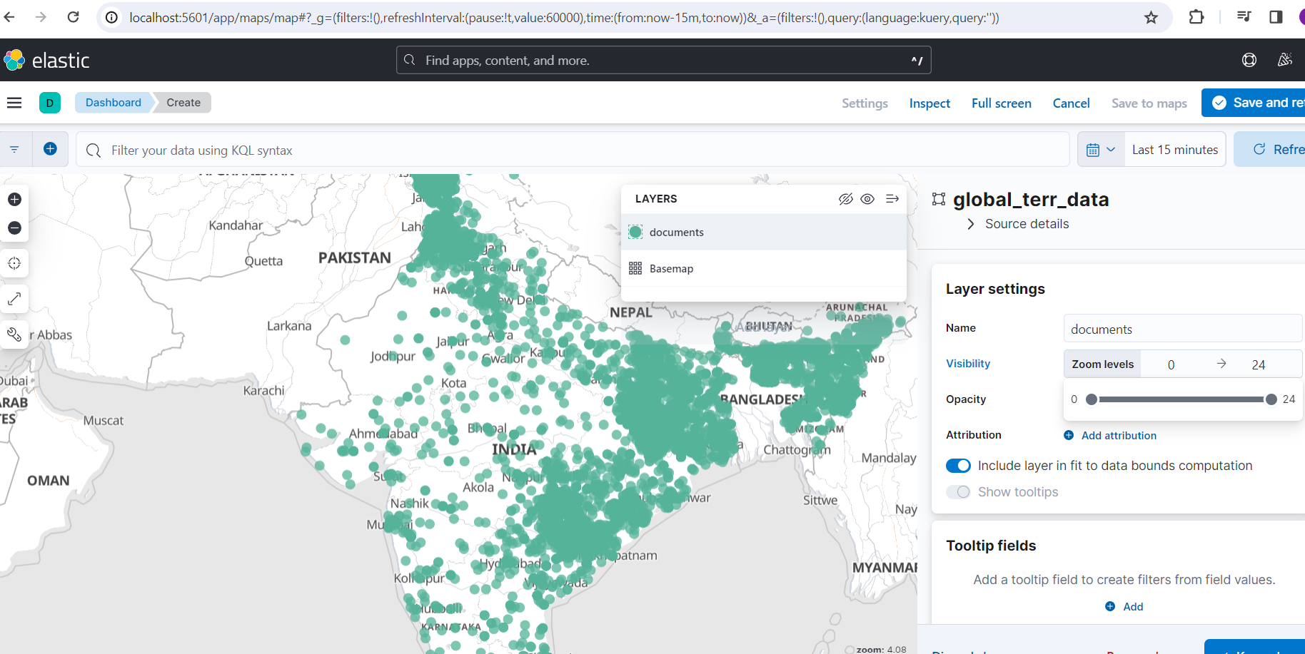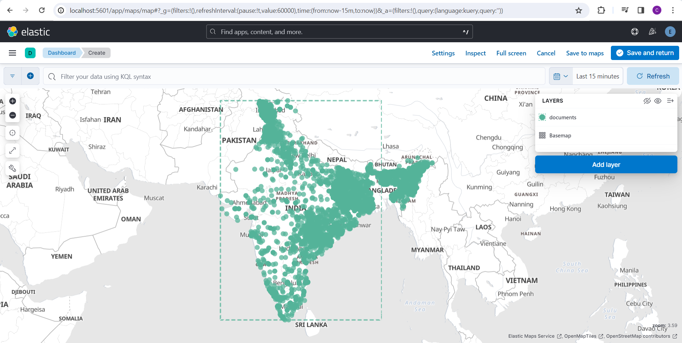

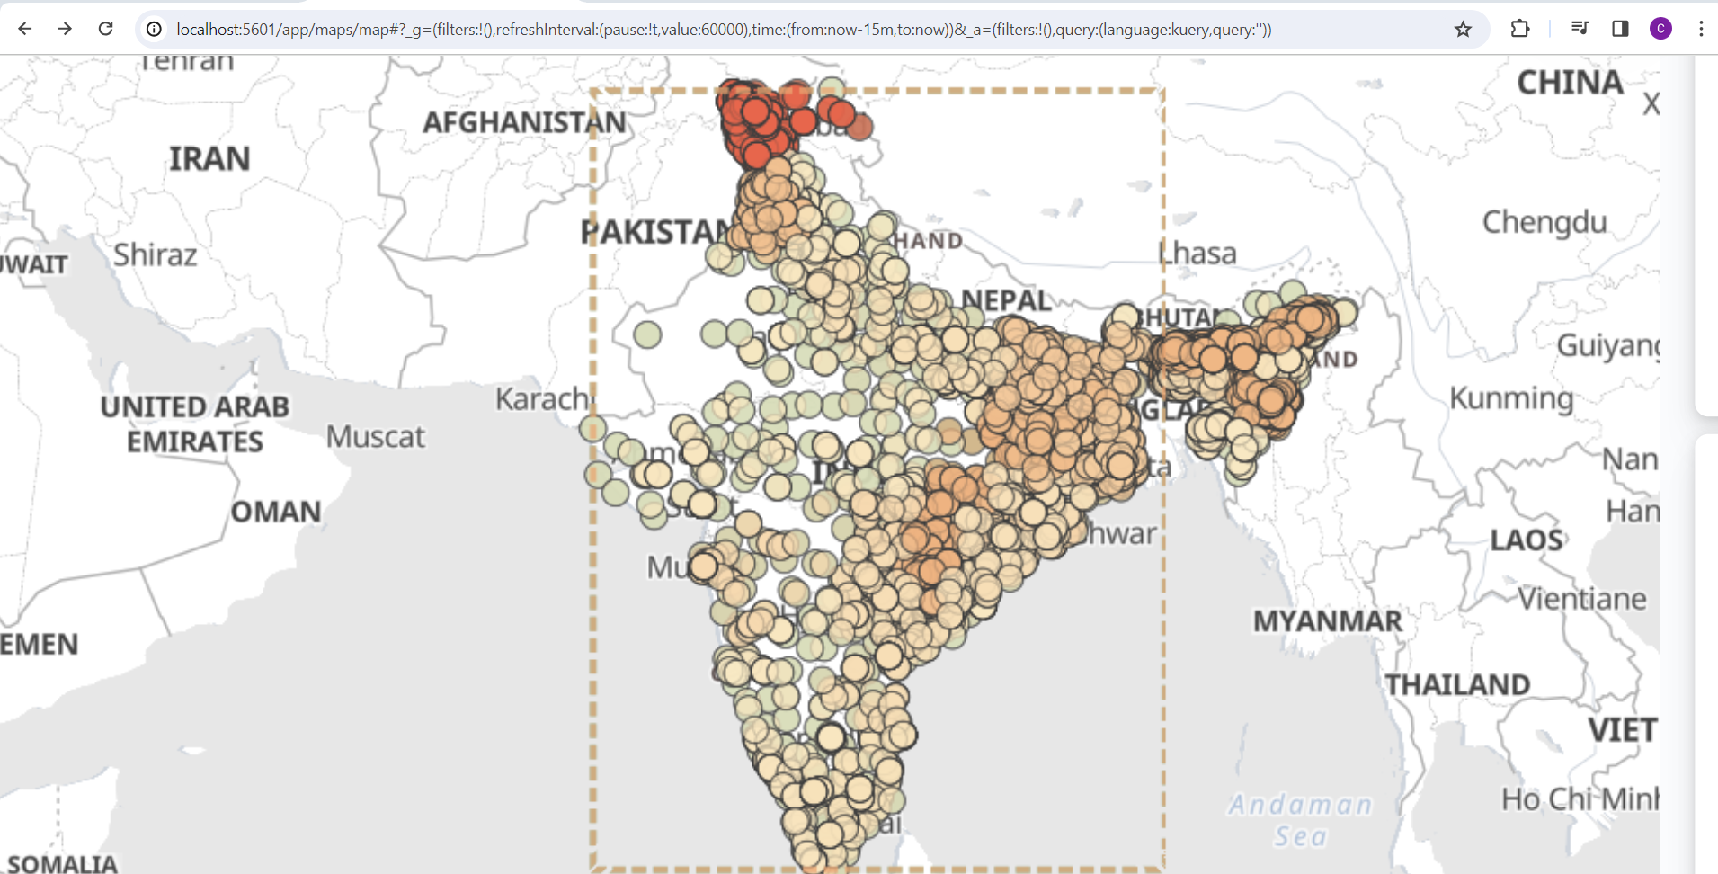

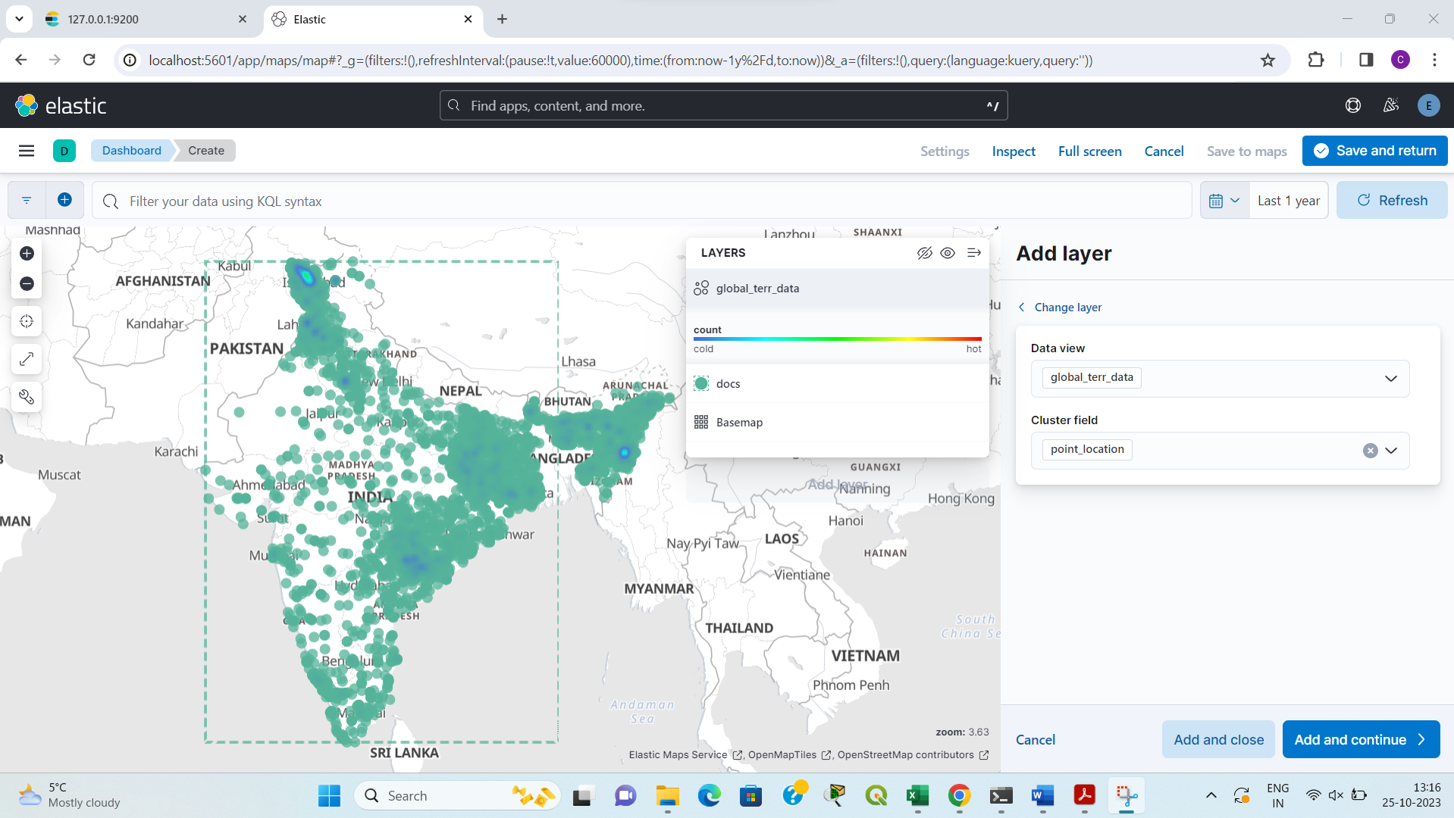

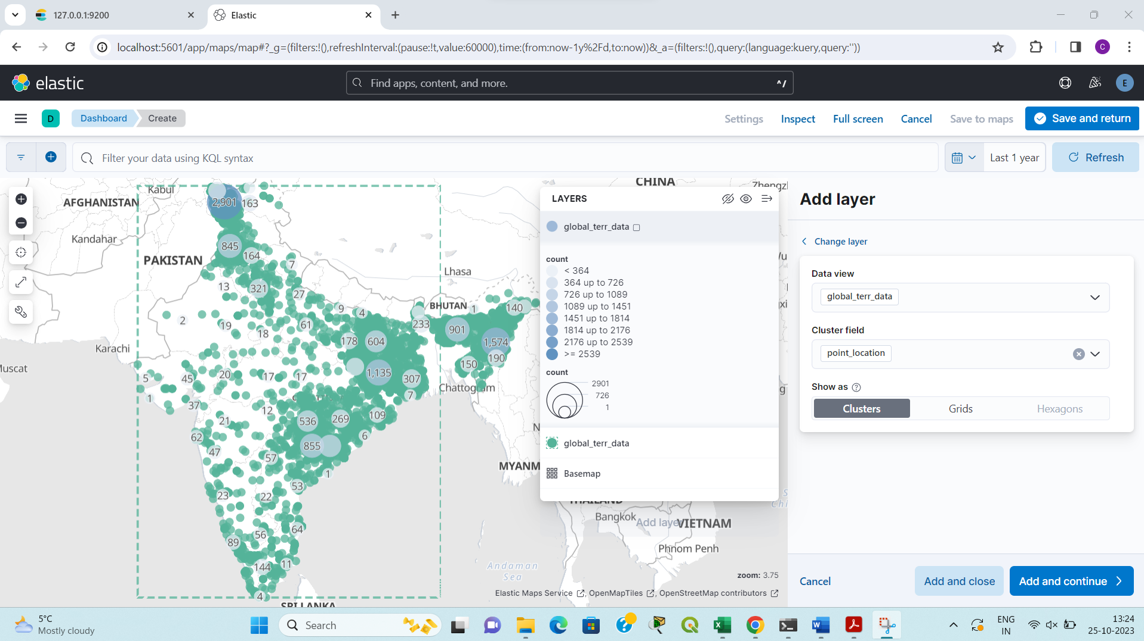

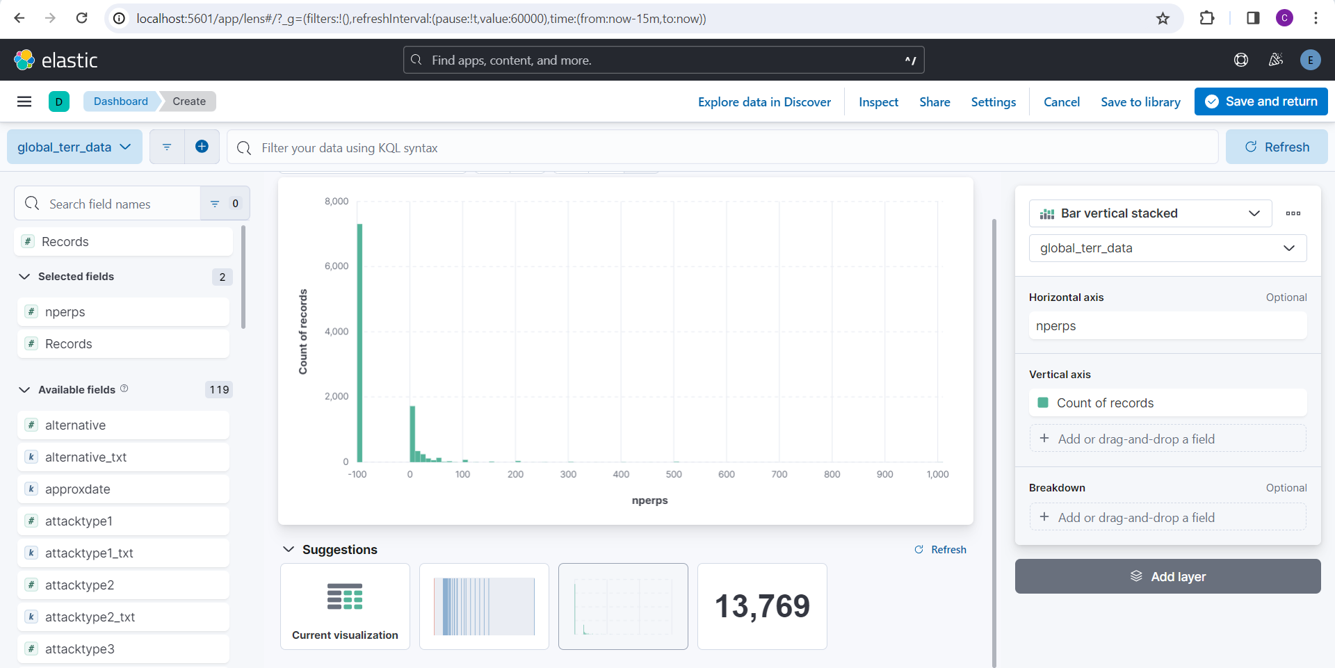

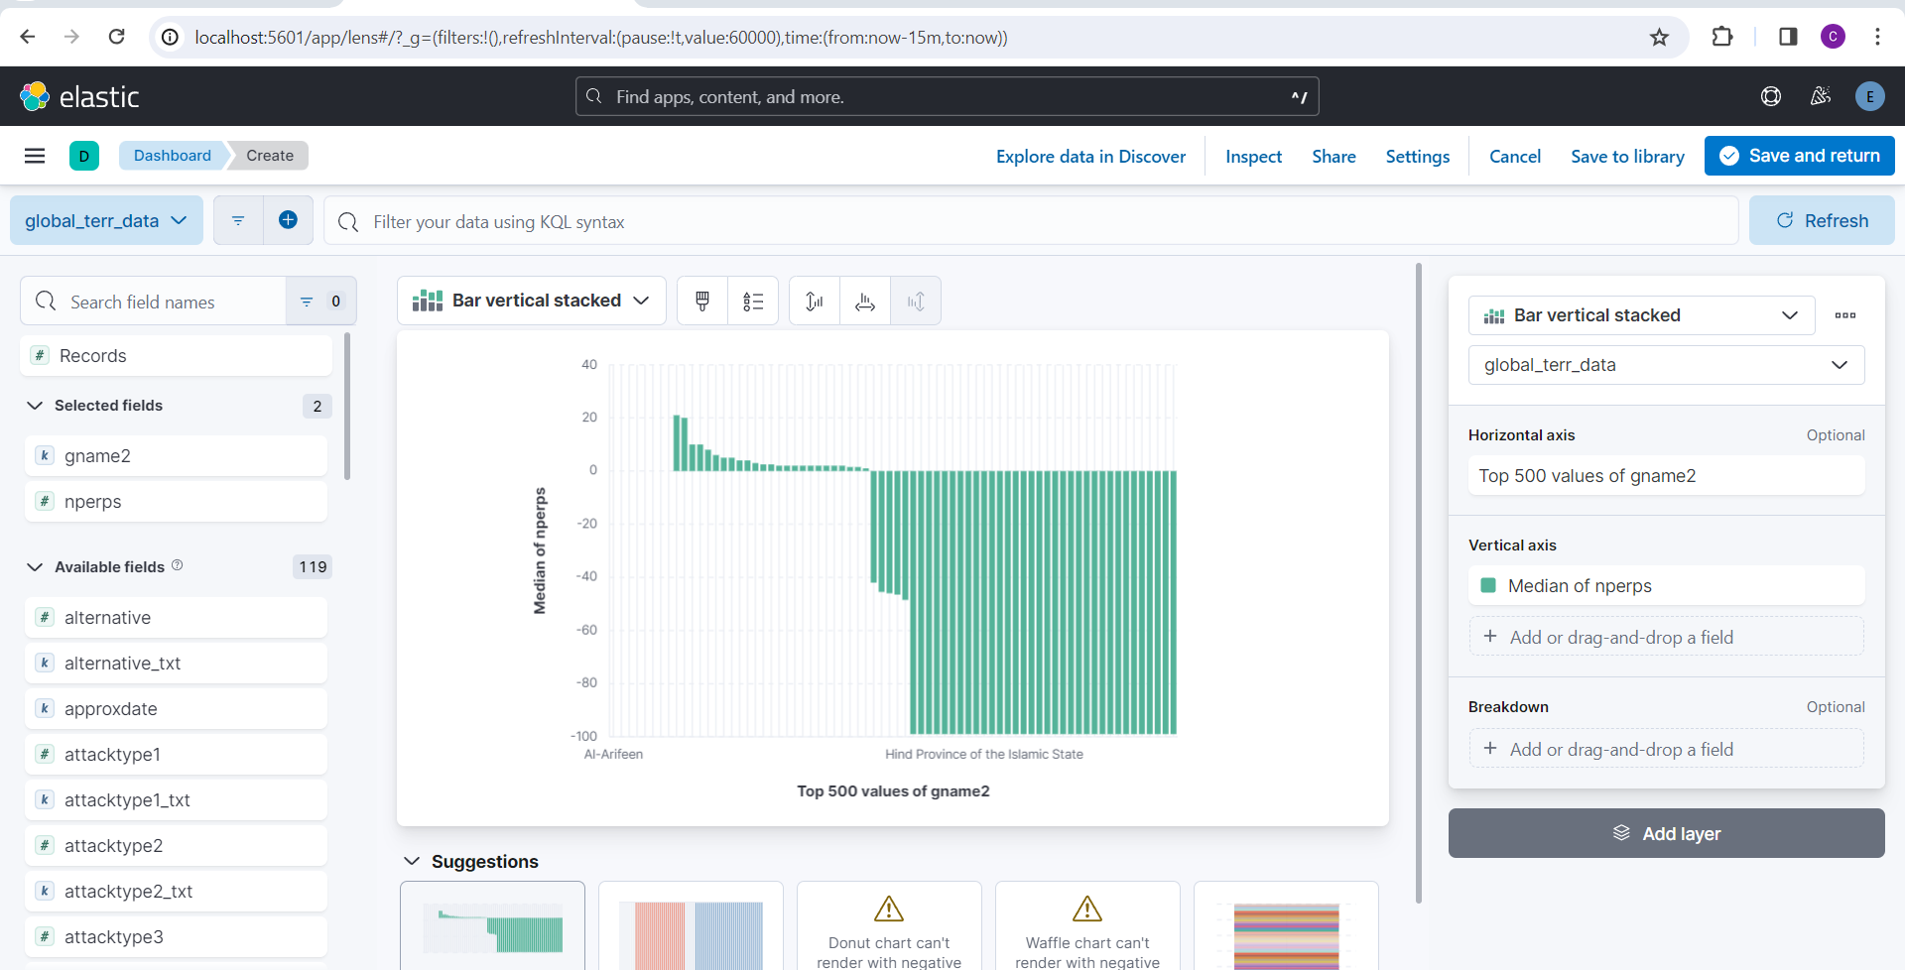

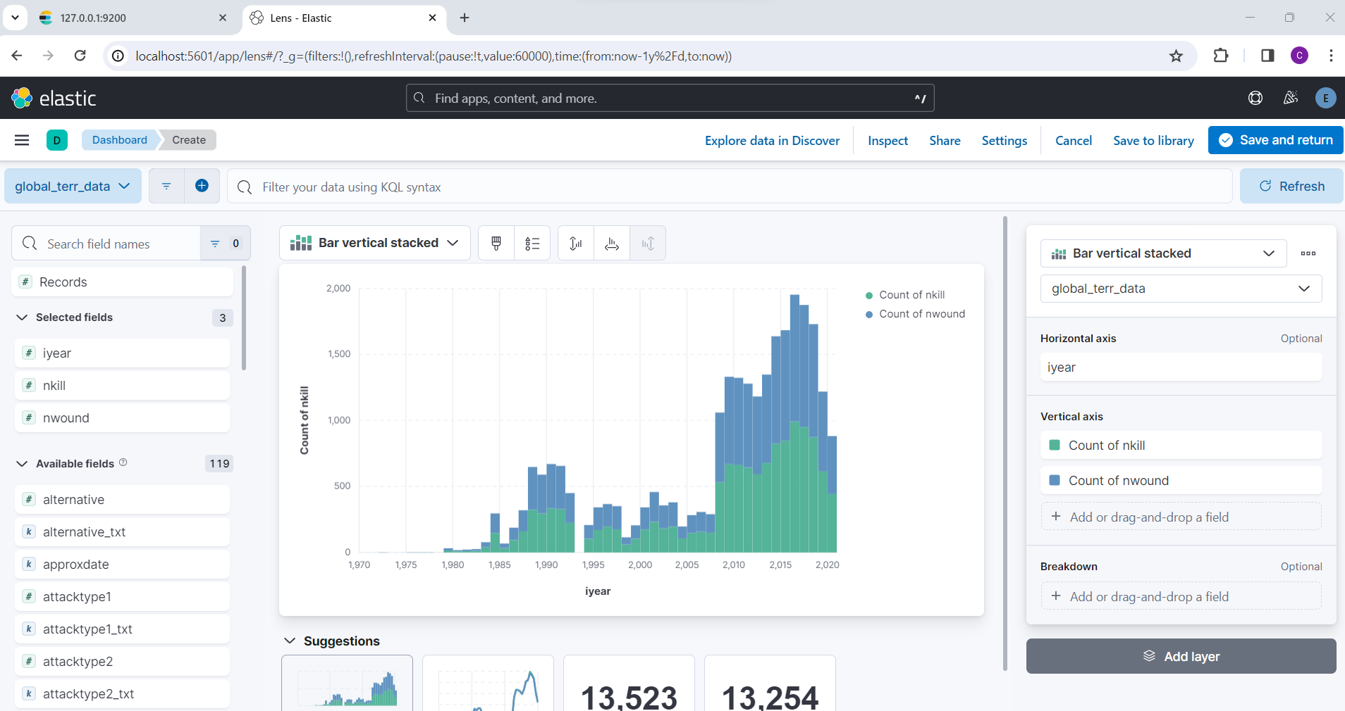

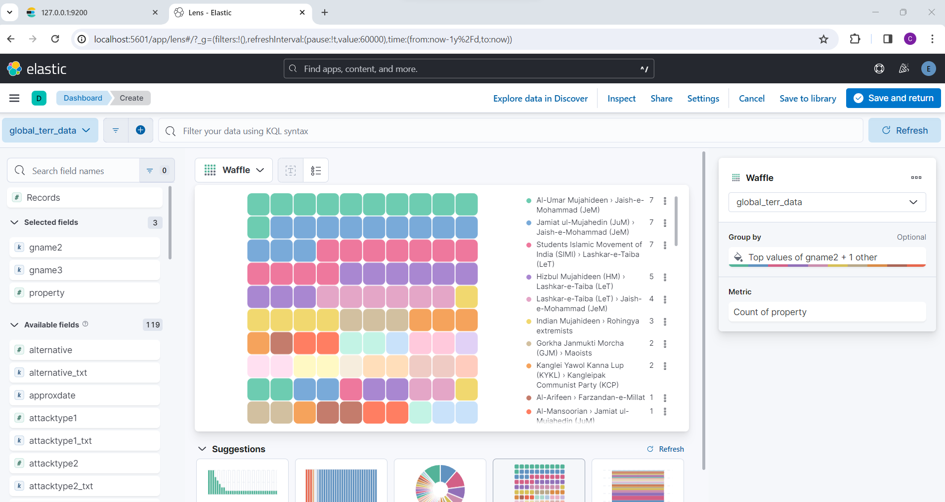

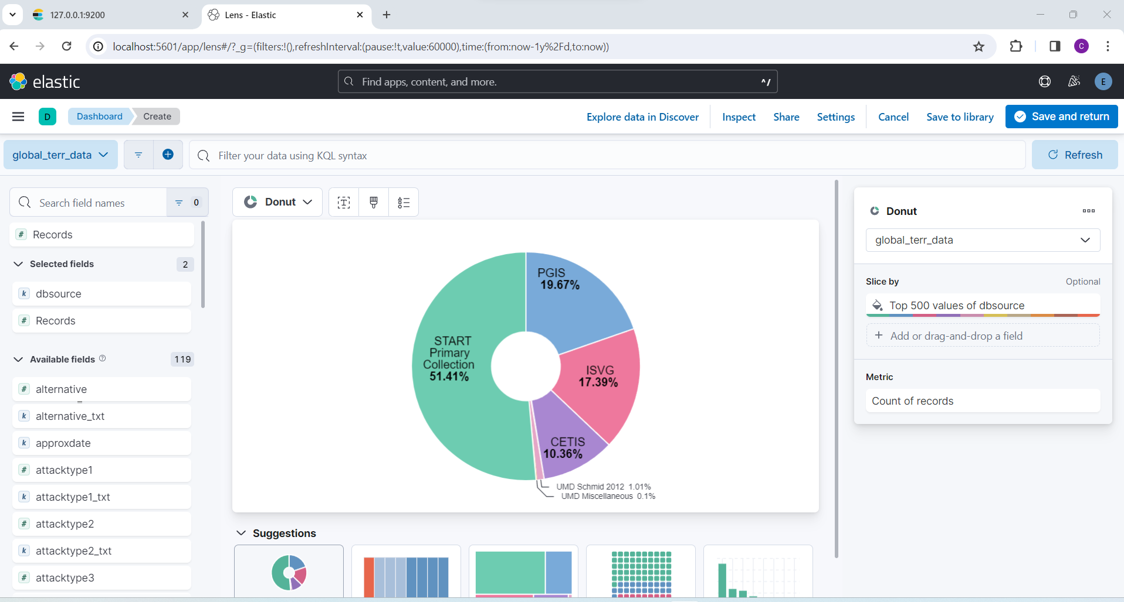

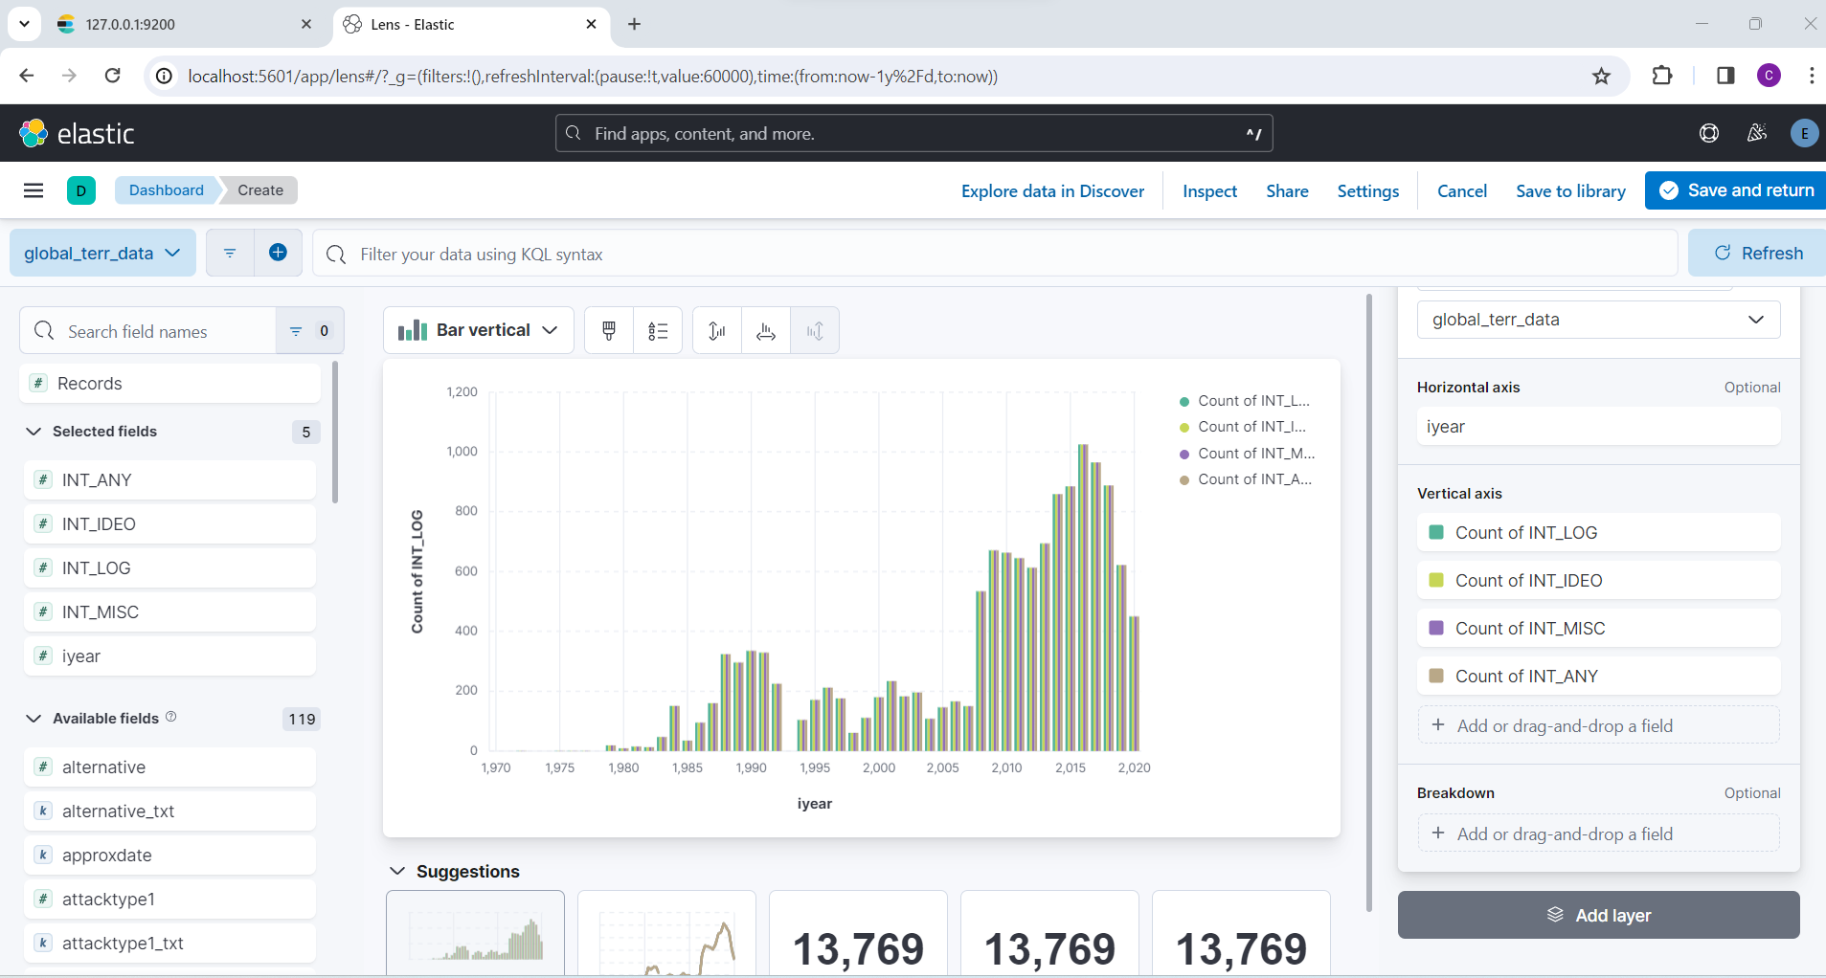

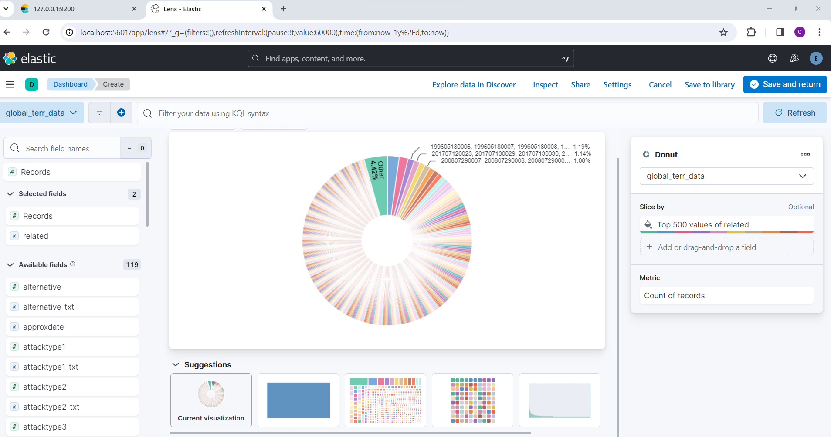

1. **Analysis.**
   * 1. **Analysis**: States with percentage of terrorists’ attacks is visualised under treechart.

**Conclusion**: Jammu and Kashmir have faced maximum number of attacks followed by chattisgarh, assam, Manipur and Jharkhand. But the difference between the percentage of first two states is huge. Also, max number of attacks took place between 1990 and 1991 with J&K being at the half of the percentage of attacks in country.

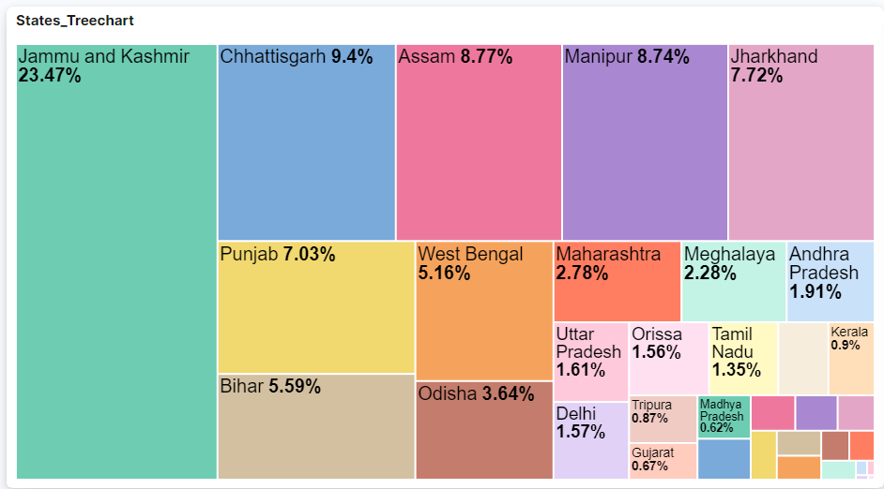

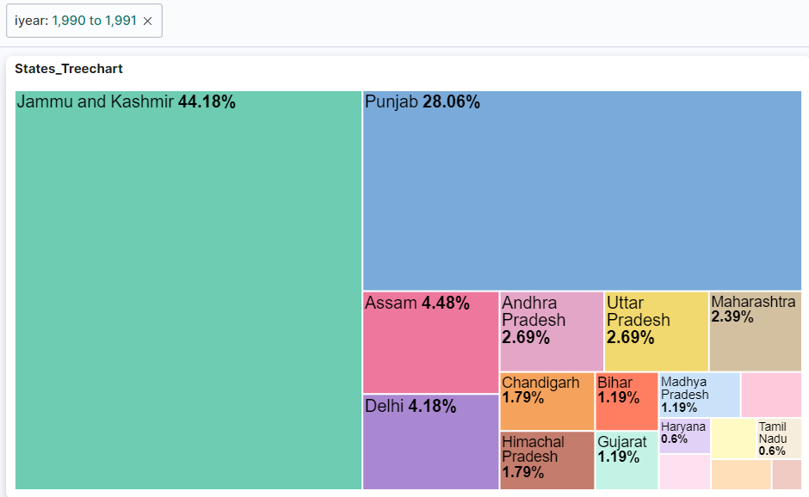

* + 1. A depiction of tag chart for years with attacks spread over various months.

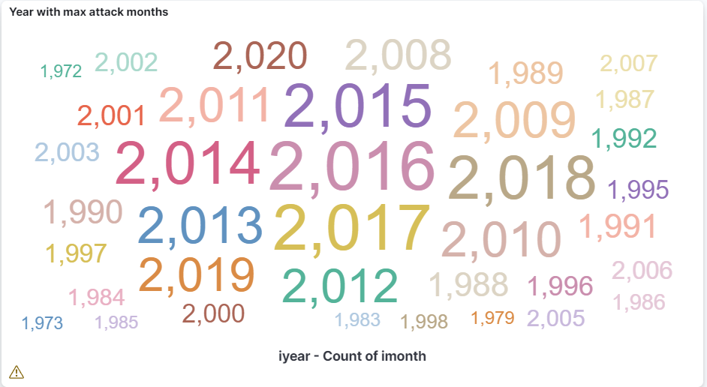

* + 1. **Analysis**: States with percentage of attacks in different cities in it.

**Conclusion**: Major cities with max no of attacks include Srinagar followed by Imphal.

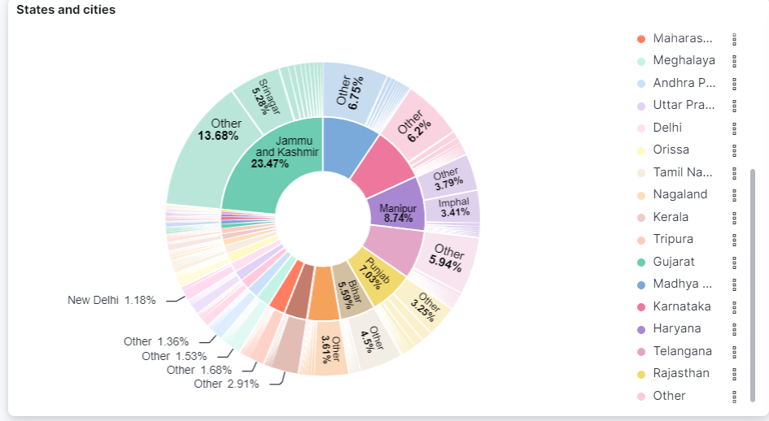

* + 1. **Analysis**: Months with number of attacks in it.

**Conclusion**: Max number of attacks were in summer with May and Apr leading the table.

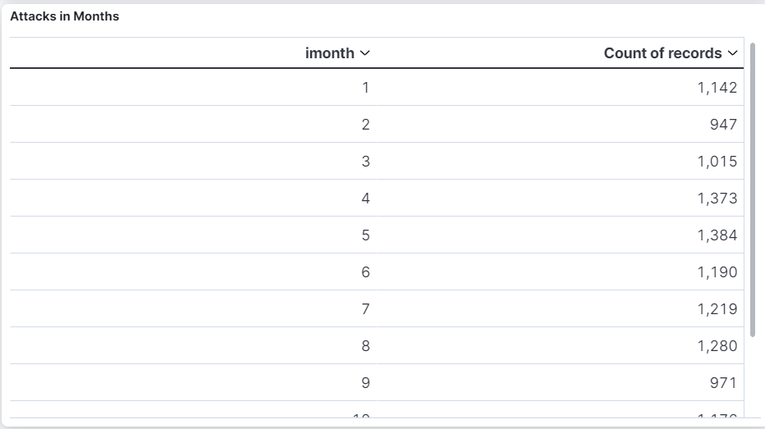

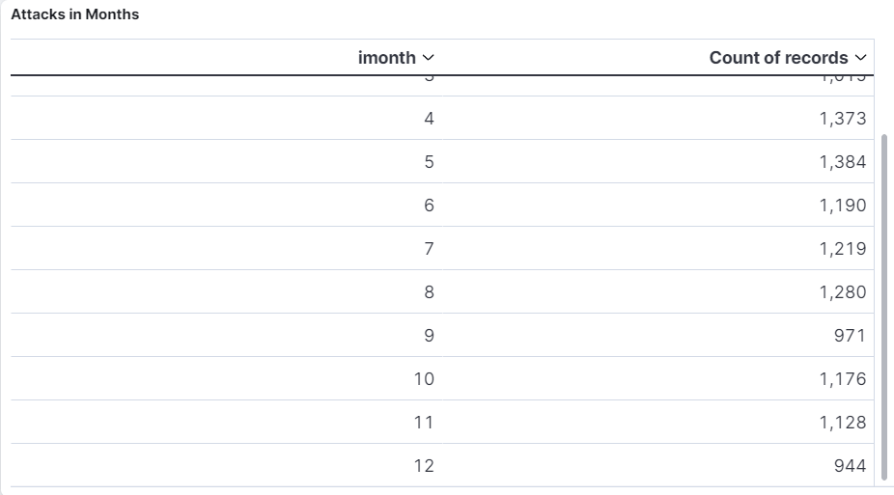

* + 1. **Analysis**: Attack types over the years.

**Conclusion**: Bombing/ Explosion and Hostage taking is the main means of attacks by various groups with armes assault being the main subtype.

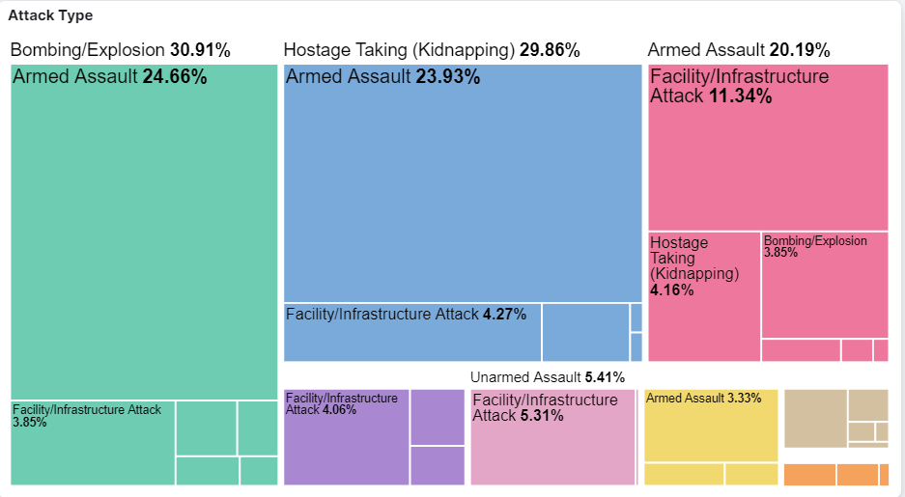

* + 1. **Analysis**: Number of attacks by different groups.

**Conclusion**: Jaish-e-mohammad and lashkar are the main terrorists groups attacking the country followed by Lashkar-e-taiba.

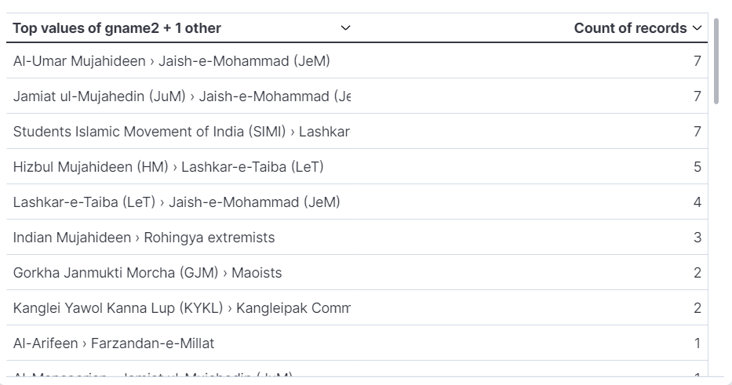

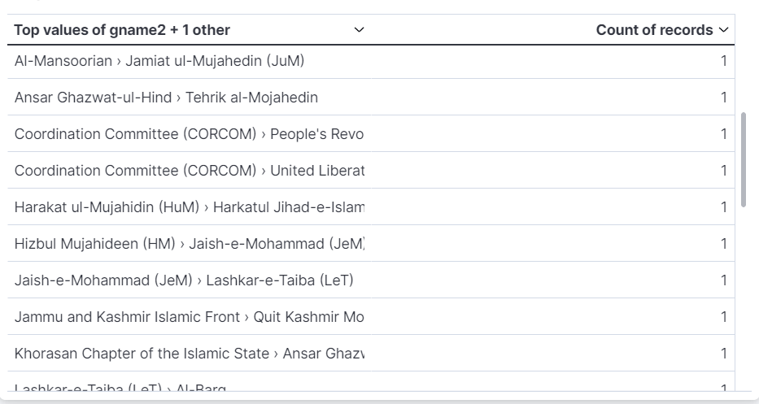

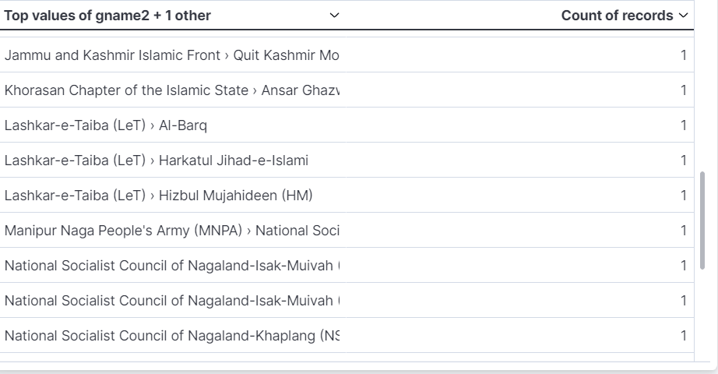

* + 1. **Analysis**: Various weapons used in the attacks.

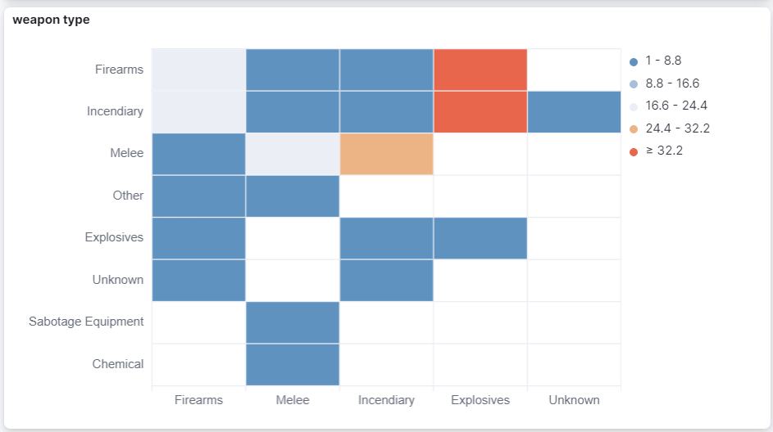

* + 1. **Analysis**: Weapons used in various attacks with subtypes.

**Conclusion**: Out of all Explosives and Firearms are used in massive amount.

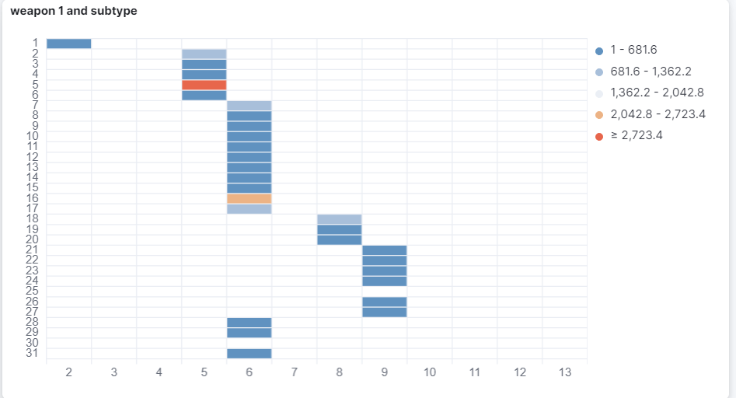

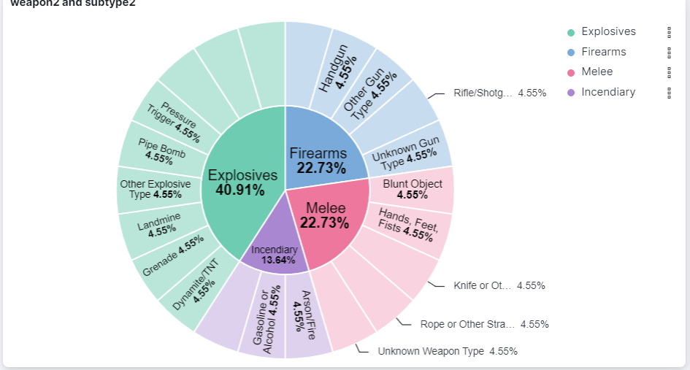

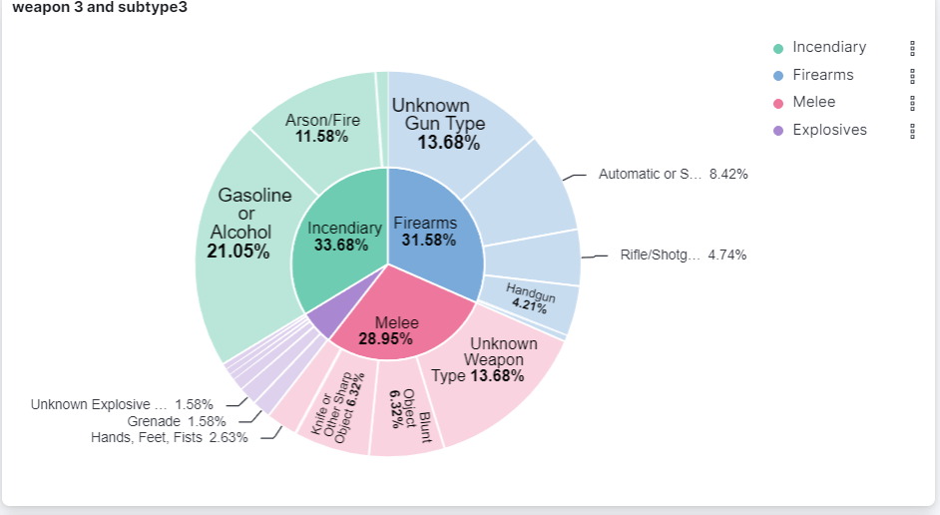

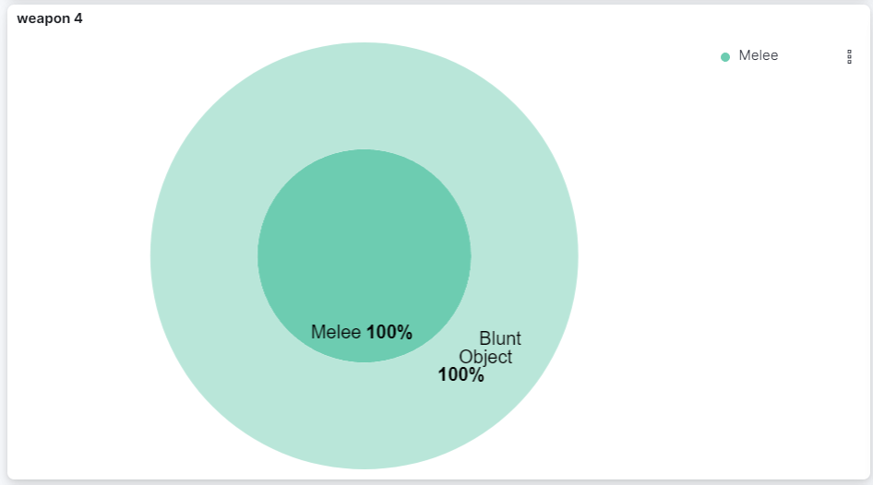

* + 1. **Analysis**: The mean of specificity.

**Conclusion**: 1 = event occurred in city/village/town and lat/long is for that location

2 = event occurred in city/village/town and no lat/long could be found, so coordinates are for centroid of smallest subnational administrative region identified

3 = event did not occur in city/village/town, so coordinates are for centroid of smallest subnational administrative region identified

4 = no 2nd order or smaller region could be identified, so coordinates are for center of 1st order administrative region

5 = no 1st order administrative region could be identified for the location of the attack, so latitude and longitude are unknown

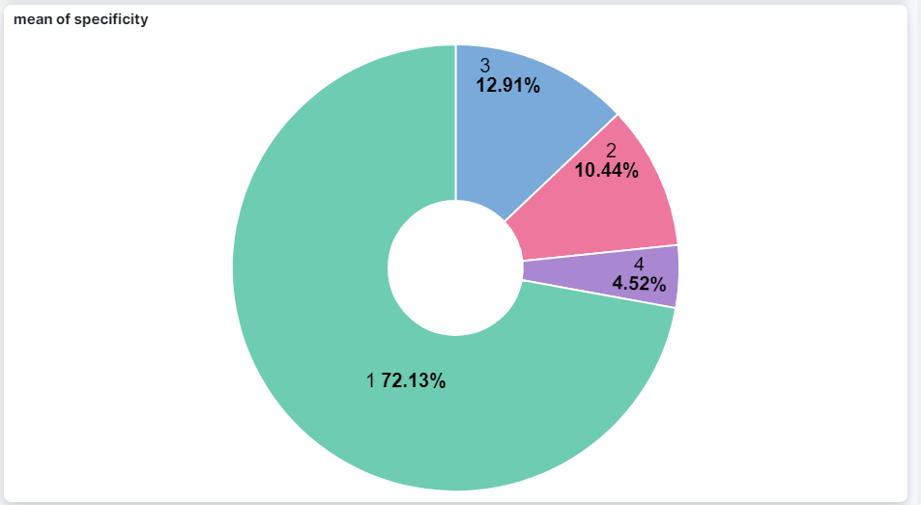

* + 1. **Analysis**: Duration of event.

**Conclusion**: 1 depicts duration more than 2 hours. Max events ended up before that.

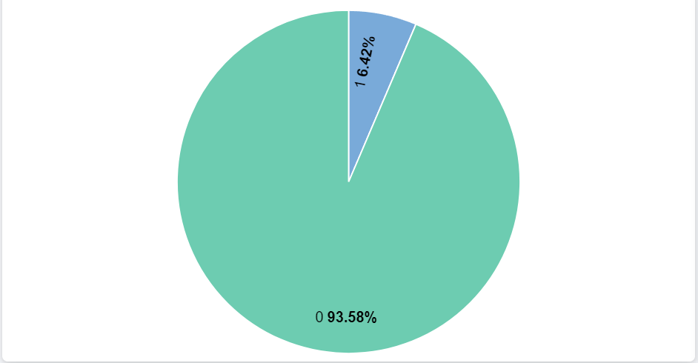

* + 1. **Analysis**: Day and month wise records of events.

**Conclusion**: 15/4 and 26/1 marked as days with max no of attacks followed by other dates mentioned in image 3.

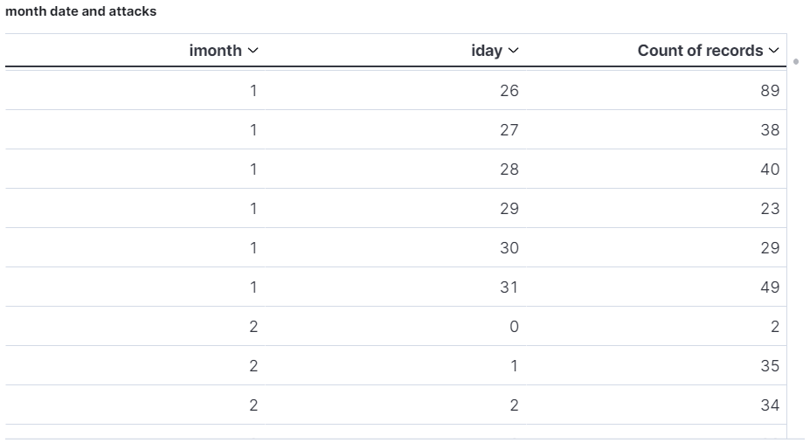

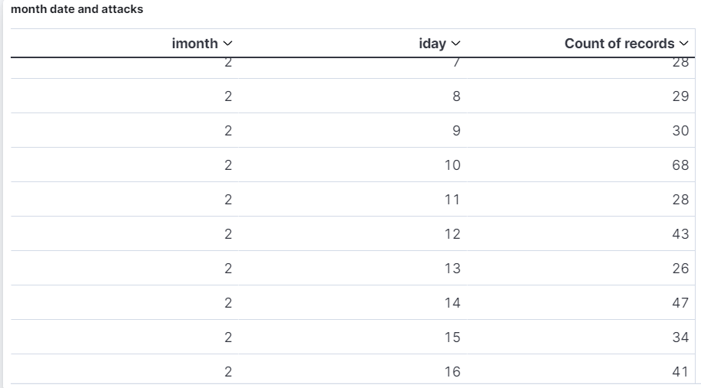

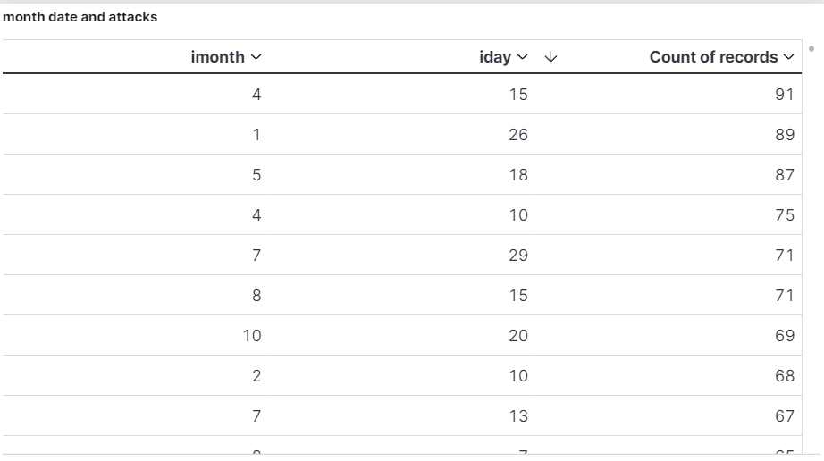

* + 1. **Analysis**: Vicinity.

**Conclusion**: Attacks occurring in city is 90% more than the incident occurred in the immediate vicinity of the city in question.

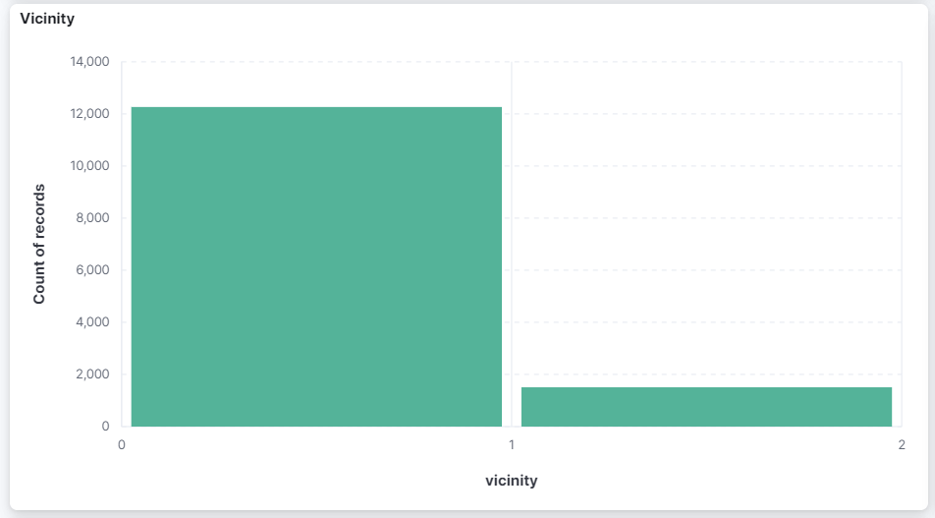

* + 1. **Analysis**: Doubt terrorism proper.

**Conclusion**: In 11471 cases, there’s no doubt of terrorist attack. In 1352 events, there’s a doubt whether act is of terrorism or not. In 946 cases, data was not included in database related to doubter.

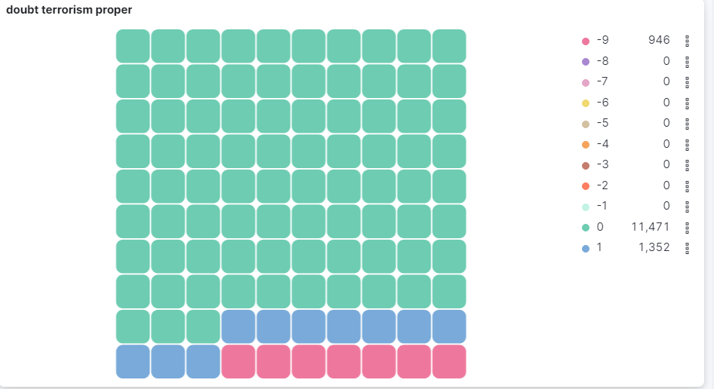

* + 1. **Analysis**: Multiple.

**Conclusion**: In 1674 cases, attack was part of multiple incidents while in 12095 it was not.

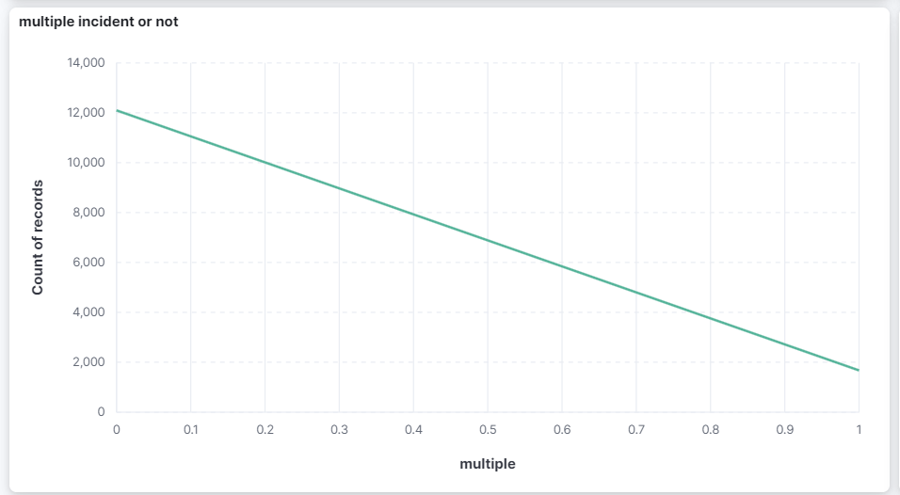

* + 1. **Analysis**: Success.

**Conclusion**: Success of a terrorist strike is defined according to the tangible effects of the attack. The same has been depicted in line graph over the years.

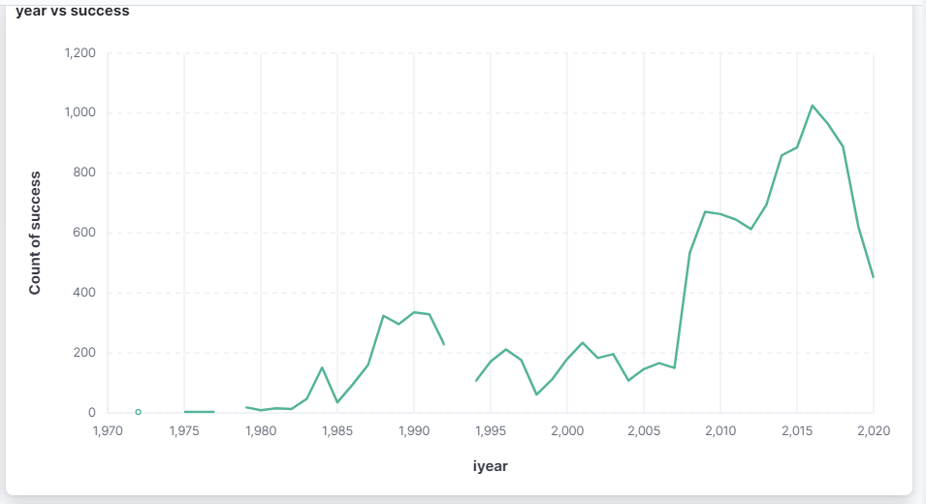

* + 1. **Analysis**: Success of terrorists in various states over the years.

**Conclusion**: Terrorists were able to convert their events into success in J&K followed by other states with a difference of huge margin.

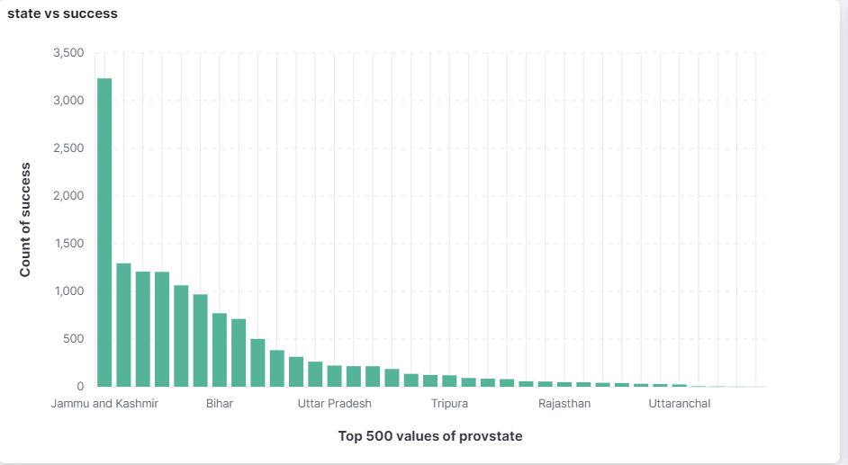

* + 1. **Analysis**: States with attack being part of multiple events.

**Conclusion**: J&K marked as first followed by chattisgarh, assam and Manipur where multiple events were converted in attack.

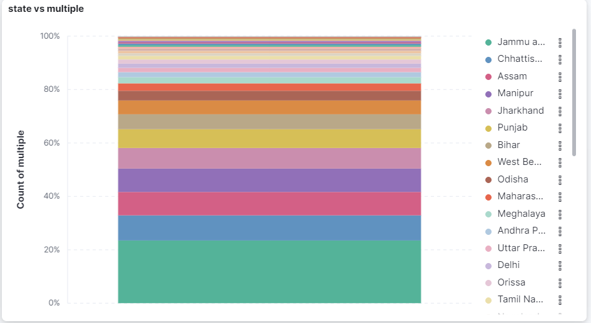

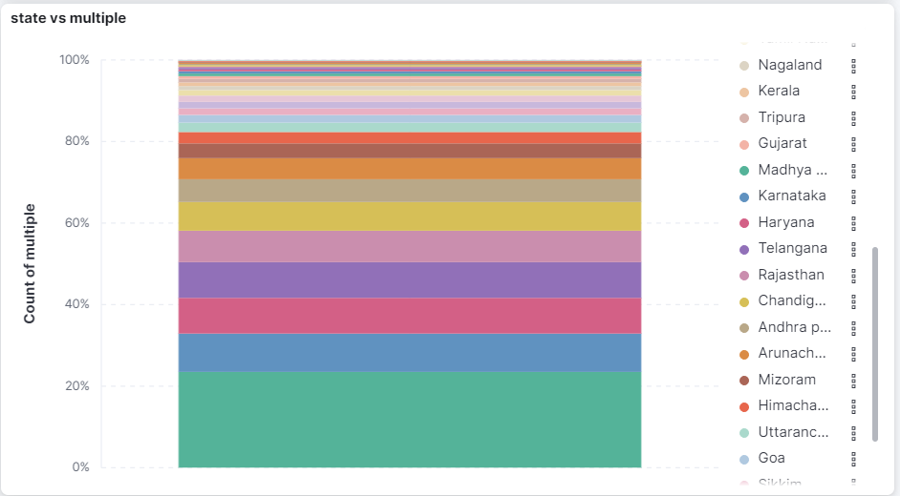

* + 1. **Analysis**: States with suicide attacks.

**Conclusion**: The depiction of states and number of suicide attacks in there in waffle with J&K being first followed by chattisgarh.

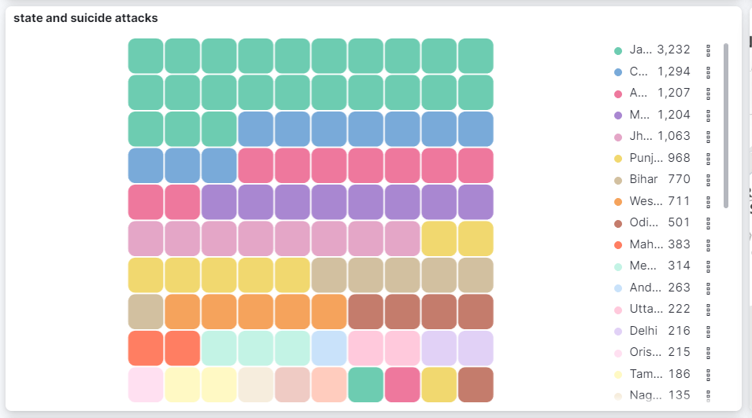

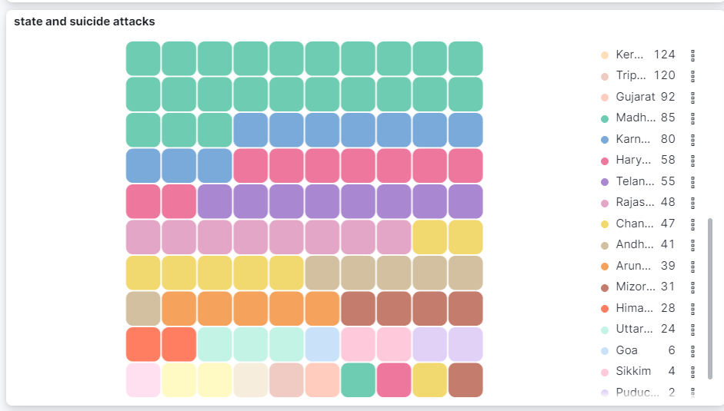

* + 1. **Analysis**: Region map of events.

**Conclusion**: Circular areas depicting areas of events across the nation.

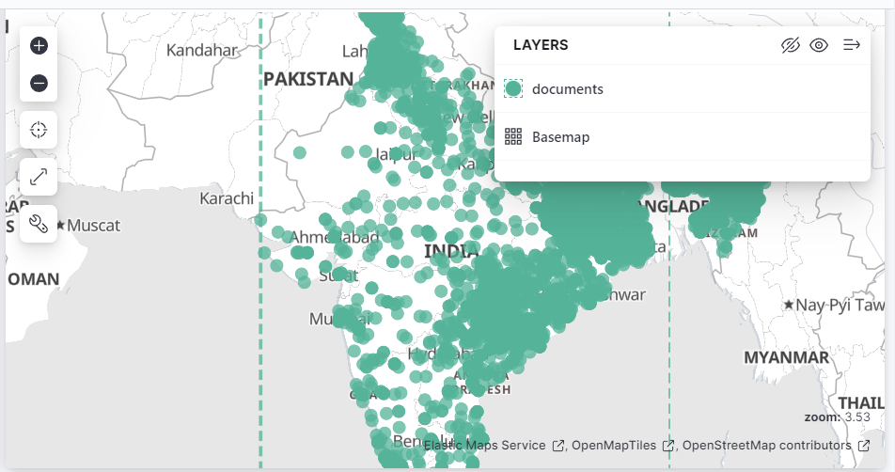

* + 1. **Analysis**: Region map of events.

**Conclusion**: Density of number of events across various parts of the nation.

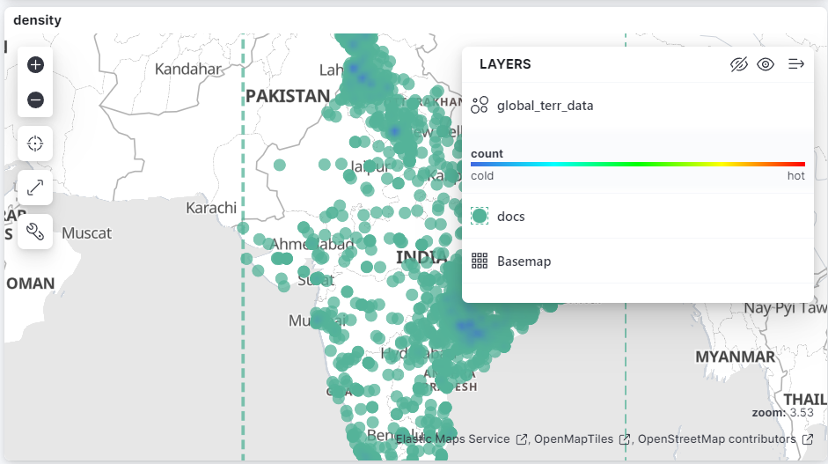

* + 1. **Analysis**: Region map of events.

**Conclusion**: The number of events depicted on region map.

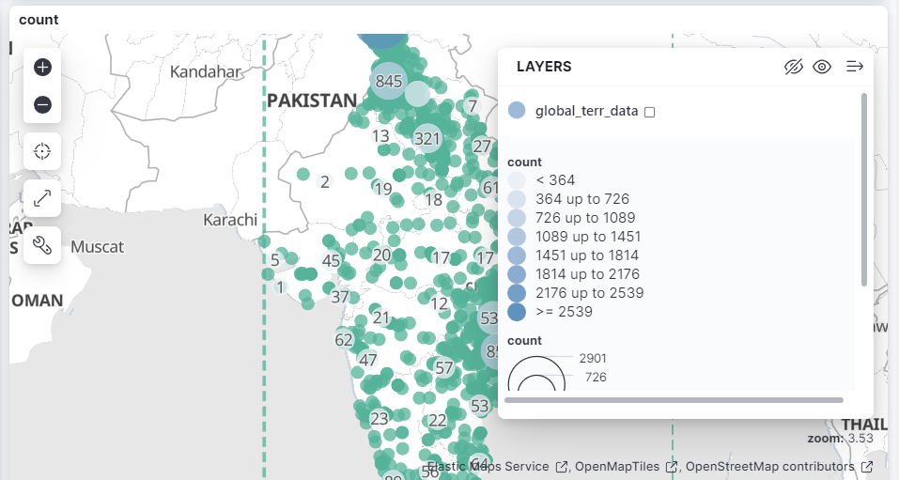

* + 1. **Analysis**: Numbers of terrorists in various events.

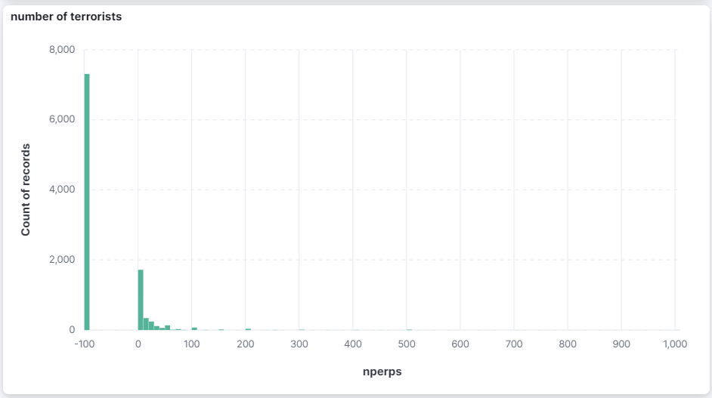

* + 1. **Analysis**: Number of attackers attacking from different terrorists group.

**Conclusion**: Groups like Student Islamic people of india (21), UPDS(20) has maximum numbers of attackers while groups as Lashkar attacked with 2-3 terrorists while for many groups the data is still unknown.

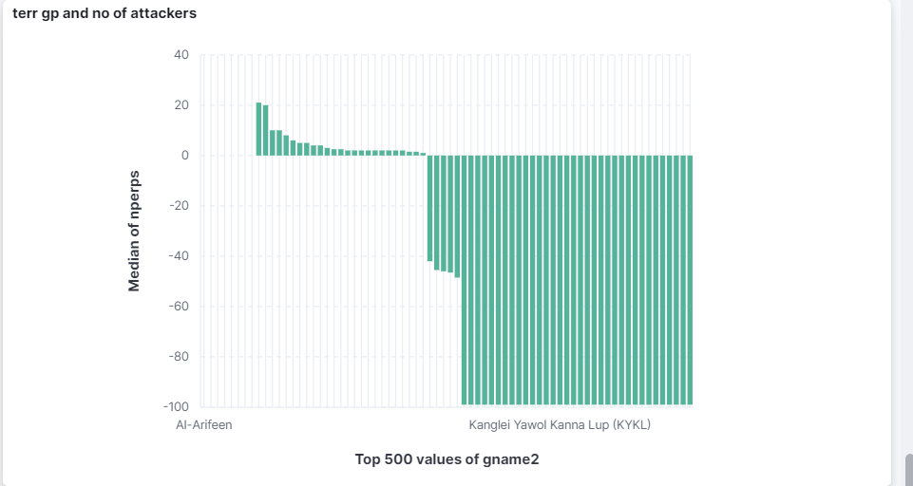

* + 1. **Analysis**: Number of kills, wounded cases per year.

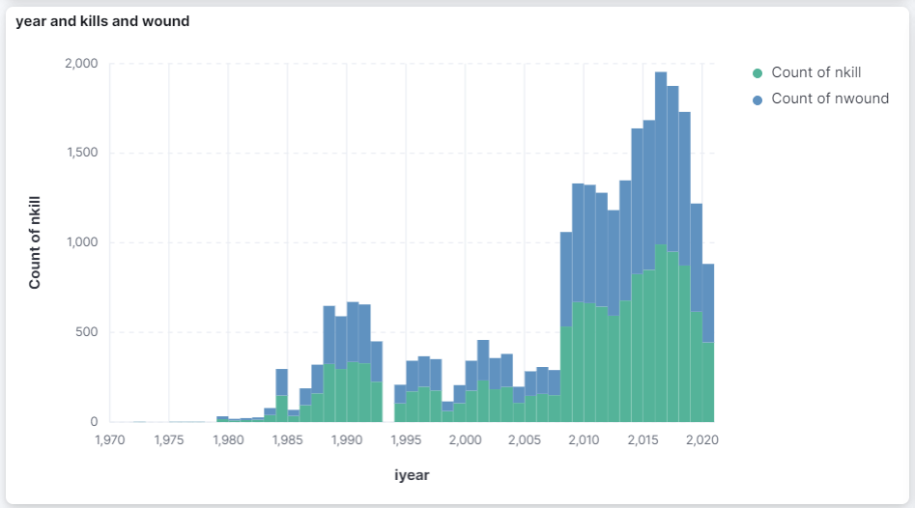

* + 1. **Analysis**: Terrorists groups and Property.

**Conclusion**: Max damage of propert has been done by JeM, LeT.

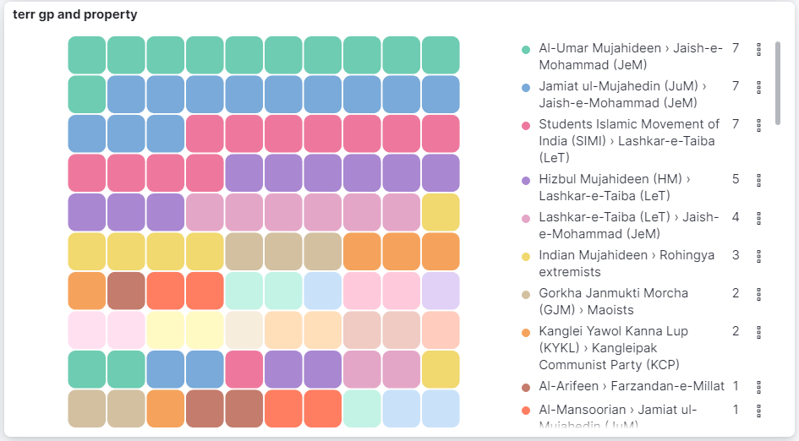

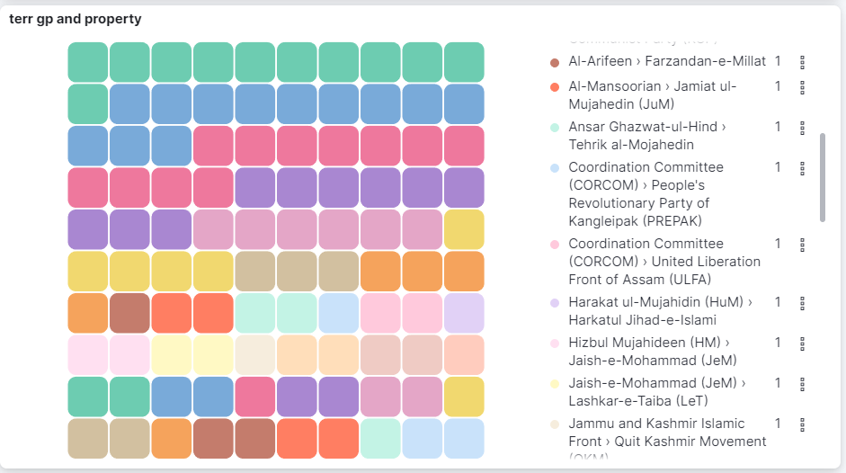

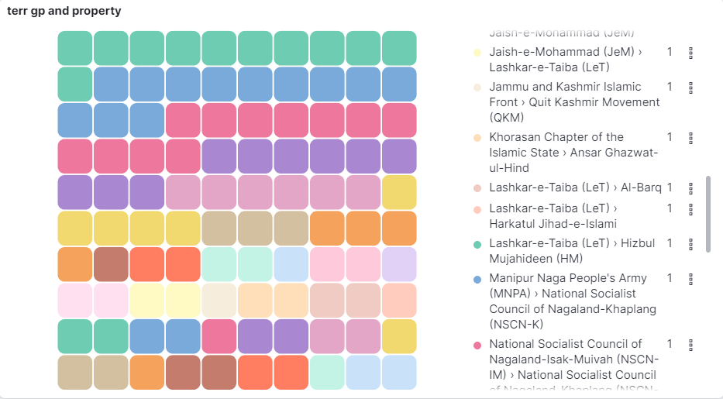

* + 1. **Analysis**: Db Source.

**Conclusion**: Source of information of the database.

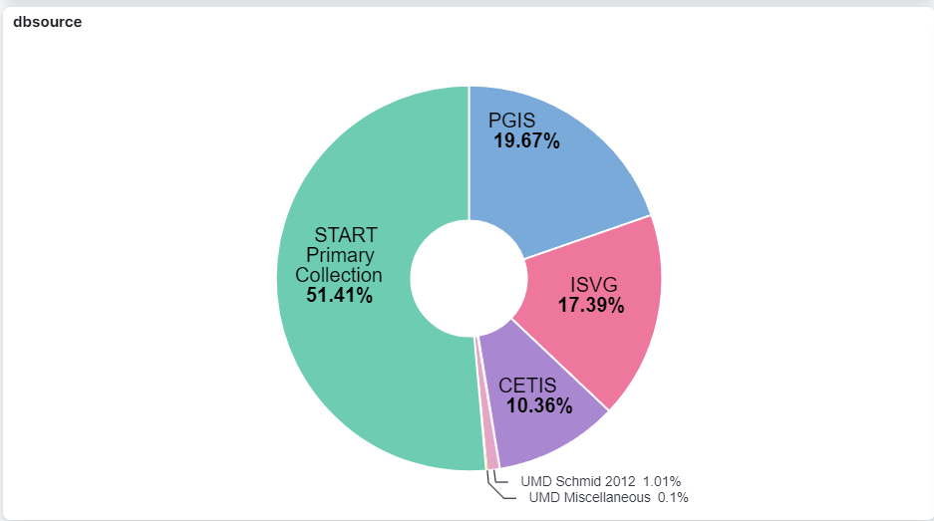

* + 1. **Analysis**: Yearly prediction of int log, int ideology, int any, int misc is depicted in the vertically stacked graph.

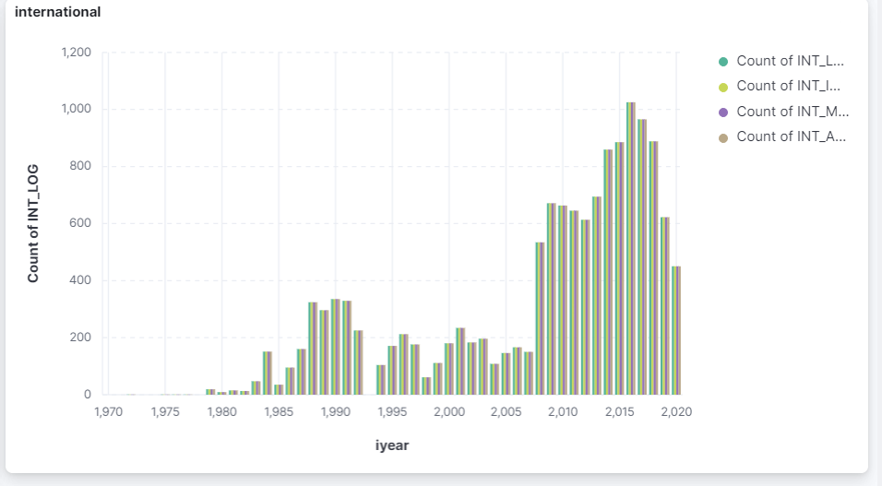

(ab) **Analysis**: Related (When an attack is part of a coordinated, multi-part incident the GTD IDs of the related incidents are listed here, separated by commas.)

